# 



**NEWS REPORTER**

**DOCUMENTATION**

|  |  |
| --- | --- |
| **Authors** | **C2305L – Group 1** |
| **Trịnh Tuấn Hiệp (Leader)**  **Nguyễn Minh Đức**  **Dương Văn Hiệp**  **Trần Đức Minh**  **Nguyễn Việt Anh** |
| **Date** | **27/01/2024** |
| **Instructor** | **Tô Hoàng Anh** |

Hanoi, 2024

**Expressions of Gratitude**

Firstly, we would like to express our heartfelt gratitude Aptech Training Center for including the EProject module in the curriculum, which allowed us to gradually gain experience in teamwork, group activities, and various other tasks. We also received enthusiastic support from the center, and I would like to extend our deep thanks to Aptech for providing us with the opportunity to get hands-on experience, even through it was just a small project.

For a student, whether at a school or a training center, the culmination of a course or semester is always a testament to the knowledge acquired after months of studying. During the process of completing this project, in addition to our team’s efforts, we would not have been able to do our job well without the wholehearted guidance of Mr.Tô Hoàng Anh – an IT instructor at Aptech International Programming Training Center. We would like to extend our sincerest thanks to him.

Furthermore, we would like to express our heartfelt gratitude to our friends who encouraged, motivated, and assigned us in completing our project.

We sincerely thank you !

**Group 1**

**Index**

**1.** **Problem Definition………………………………………………………………3**

1.1. Problem Abstraction……………………………………………………..3

1.2. The Current System…………………………………………….…………3

1.3. The Proposed System…………………………………………………..…..3

1.3.1. Boundaries of the System…………………………………………...….3

1.3.2. Hardware and Software Requirements……………...……………….3

**2.** **Customer Requirements Specification………………………….…….…….…..3**

2.1. Users of the System…………………………...…………………...……...3

2.2. System functions………………...…………………………………...…...3

**3.** **System Designs…………………………………………….………………...……3**

3.1. Entity Relationship Diagram……………………………………………..3

3.2. Database Design……………………………………………..…………..…3

3.3. Sitemap………………………………………………………………..…..…3

3.4. System fucntions design……………………………………………...…...4

**4.** **Task sheet……………………..…………………………………………………..4**

**5.** **Validation Checklists……………………………………………………...……...4**

# Problem Definition

## Problem Abstraction

In an era characterized by information overload and the rapid dissemination of news, it is essential to have reliable and concise sources of information. This project aims to address this need by creating a comprehensive and accessible platform that delivers timely and accurate news reports to the public. By leveraging cutting-edge technology and a team of dedicated journalists, we strive to provide an engaging news experience that empowers individuals to stay informed and make well-informed decisions.

**Information Accessibility:** The project aims to bridge the gap between the vast amount of news available and individuals' ability to access and understand it effectively. By presenting news reports in a clear and concise manner, we aim to make information accessible to a wider audience, including those who may not have the time or resources to sift through multiple sources.

**Reliable Journalism:** In an age of misinformation and the proliferation of fake news, it is crucial to establish a trusted source of journalism. This project prioritizes accuracy, fact-checking, and ethical reporting practices to ensure that the news reports provided are reliable and trustworthy, helping to combat the spread of false information.

**Timeliness:** The News Report project will prioritize delivering news in a timely manner, keeping up with the fast-paced nature of the modern news landscape. By leveraging advanced technologies and efficient news-gathering processes, we aim to provide up-to-date information that reflects the latest developments.

**Comprehensive Coverage**: The project will cover a wide range of topics, including politics, economics, technology, science, and more. By offering comprehensive coverage across various fields, we strive to cater to diverse interests and ensure that users can access news reports that align with their preferences and needs.

**User Empowerment:** Informed citizens are essential for a functioning democracy. By providing accurate and accessible news reports, this project aims to empower individuals with the knowledge they need to participate actively in societal discussions, make informed decisions, and engage with important issues that affect their lives.

In conclusion, the News Report project seeks to address the challenges posed by information overload and the spread of misinformation by providing accessible, reliable, and timely news reports. By empowering individuals with accurate information, we aim to foster an informed society and contribute to the overall well-being of our communities.

## The Current System

The Current System of the News Reporter website is a comprehensive platform designed to deliver the latest news and information to its users. The system includes the following key components:

* **News Articles:** The website features a wide range of news articles covering various topics such as politics, entertainment, sports, technology, and more. These articles are regularly updated to provide users with current and relevant information.
* **Categorization:** The news articles are organized into different categories, making it easier for users to navigate and find articles of interest. Categories may include sections like politics, business, lifestyle, health, and others, allowing users to explore news content specific to their preferences.
* **Search Functionality:** The website provides a search feature that enables users to quickly find news articles by entering keywords or phrases related to their desired topic. This feature helps users locate specific information or articles they are looking for efficiently.
* **User Interaction:** The system allows users to engage with the content and each other through various interactive features. Users can leave comments on articles, share articles on social media platforms, and participate in discussions or forums related to the news topics.
* **Mobile Responsiveness:** The News Reporter website is designed to be mobile-friendly, ensuring that users can access and read news articles seamlessly on different devices such as smartphones and tablets. This enhances the user experience by providing flexibility and convenience.
* **Updates and Notifications:** The system may offer options for users to subscribe to newsletters or receive notifications about breaking news, new articles in specific categories, or updates related to their areas of interest. This keeps users informed and up to date with the latest developments.

The Current System of the News Reporter website combines the elements of categorization, search functionality, user interaction, mobile responsiveness, and updates to deliver a comprehensive news experience to its users. It aims to provide timely, reliable, and engaging news content to keep users informed and engaged.

## The Proposed System

The News Reporter website is a platform that aims to provide users with up-to-date news articles and information. It includes several key features:

* Home Page with Categories: The website's home page serves as a central hub where users can access various news categories. These categories help users navigate and find news articles that align with their interests. By selecting a specific category, users can explore news stories in that particular domain.

- Contact Us: This section allows users to engage with the website administrators or customer support team. Users can leave feedback, report issues, ask questions, or provide suggestions. Additionally, the Contact Us page may provide information about the website's physical branch or office location, facilitating offline communication.

* User Login and Registration: The website offers a user login and registration system. New users can create an account by completing a registration process, which typically involves providing personal information, such as a username, email address, and password. Registered users can then log in to access additional features, such as personalized news recommendations, bookmarking articles, or engaging in community discussions.
* User Management: This feature enables users to manage their accounts and preferences. Users can update their profile information, change passwords, and modify notification settings. User management may also include the ability to delete an account if desired.

The News Reporter website aims to provide a user-friendly experience with easy access to news articles categorized by topic. It includes a Contact Us section for user feedback and inquiries, a user login and registration system for personalized features, and user management functionalities for account customization.

## Boundaries of the System

A user or visitor to a news website is an individual who accesses the website to consume news and information. These users can be categorized into two main groups: casual users and dedicated readers.

Casual users are individuals who visit the news website sporadically or on an irregular basis. They may stumble upon the website through search engines, social media platforms, or other online sources. Casual users often have a diverse range of interests and might visit the website for specific articles, breaking news, or trending topics. They may spend a shorter amount of time on the website and are less likely to engage in long-term interactions or subscriptions.

On the other hand, dedicated readers are individuals who have a deeper commitment to the news website. They visit the website regularly, seeking reliable and up-to-date information on various topics of interest. Dedicated readers might have a subscription to the news website's premium content or newsletters, allowing them to access exclusive articles, analysis, or additional features. They often engage in discussions through comments, participate in polls or surveys, and may share articles on social media platforms.

Both casual users and dedicated readers play a crucial role in the success of a news website. Their visits, engagement, and interactions contribute to the website's traffic, visibility, and overall popularity. News websites strive to engage users by providing high-quality content, user-friendly interfaces, personalized recommendations, and interactive features to cater to the diverse needs and preferences of their audience.

It is important for news websites to understand the behavior and demographics of their users or visitors to optimize their content strategy, advertising efforts, and user experience. By analyzing user data such as page views, click-through rates, time spent on the website, and demographics, news websites can make informed decisions to enhance their offerings and meet the expectations of their audience.

In summary, users or visitors of a news website encompass a wide range of individuals, from casual users seeking specific information to dedicated readers who regularly engage with the website. Their interactions and preferences shape the content and user experience provided by the news website, making them an essential component of the online news ecosystem.

**Registered users** on a news website have the advantage of additional features and privileges that enhance their overall experience. Here's a short introduction to the capabilities of registered users:

* **Create a new Post:** Registered users have the ability to create and publish their own posts on the news website. This feature allows them to share their opinions, perspectives, or even contribute articles or news pieces to the platform. By creating a new post, registered users can actively participate in the content creation process.
* **Manage their posts:** Once registered users have published their posts, they can manage and edit their content as needed. This includes updating information, correcting errors, or adding supplementary details. The ability to manage their posts gives registered users a sense of control and ownership over their contributions to the website.
* **Leave Feedback:** Registered users can provide feedback on articles, news pieces, or other content published on the website. This feedback can be in the form of ratings, reviews, or constructive comments. By leaving feedback, registered users can engage in discussions, express their opinions, and contribute to the overall quality and improvement of the news website.
* **Leave Comments:** Registered users can leave comments on articles or news stories published on the website. This allows them to engage in conversations with other users, share their thoughts, ask questions, or provide additional information. Commenting facilitates interaction and fosters a sense of community among registered users and other readers.

These features empower registered users to actively participate in the news website's ecosystem. By creating and managing their posts, leaving feedback, and commenting on articles, registered users contribute to the diversity of content, promote healthy discussions, and help shape the overall user experience on the news website.

## Hardware and Software Requirements

When considering the choice of a code editor for software development, Visual Studio Code (VSC) stands out as a compelling choice for a variety of reasons. Here's an overview of why VSC is often favored over other options and how it meets the software requirements you mentioned:

1. **Powerful system integration:** VSC is an open-source code editor that can be easily customized and extended with a plethora of useful extensions. By adding extensions like Prettier, PHP Debug, and PHP Intelephense, you can tailor VSC to your specific development needs. These extensions facilitate code formatting, debugging, and error correction, greatly enhancing your development workflow.

1. **Large development ecosystem:** VSC boasts a thriving and active development community. This community-driven support system results in an extensive library of extensions and plugins created by developers from around the world. This means you can find solutions for a wide range of programming languages, development tools, and frameworks, including PHP. The availability of code suggestions, error checking, and other features enhances productivity and code quality.

1. **Cross-platform:**  One of VSC's standout features is its cross-platform compatibility. It is available on Windows, macOS, and Linux, making it an ideal choice for development teams and individuals who work across various operating systems. This cross-platform support ensures consistency in the development environment, simplifying collaboration and enabling developers to switch between different machines seamlessly.

**Installing Visual Studio Code on Windows**

Follow the below steps to install **Visual Studio Code** on Windows:

**Step 1:** Visit the [official website](https://code.visualstudio.com/docs/?dv=win) of the **Visual Studio Code** using any web browser like Google Chrome, Microsoft Edge, etc.

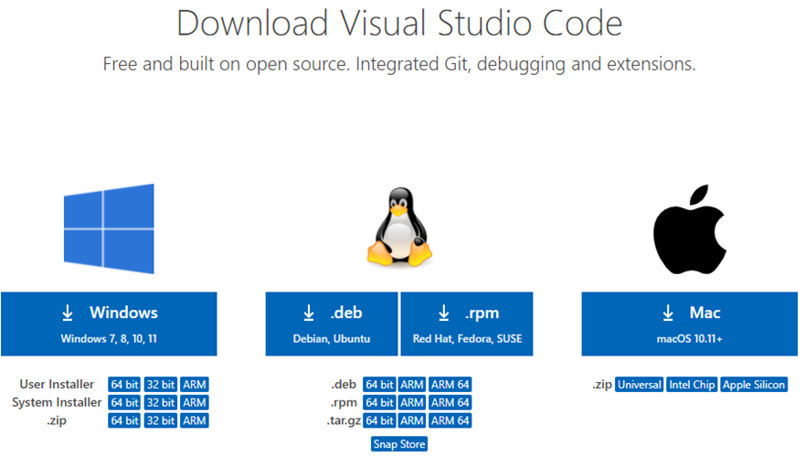

**Figure 1**

**Step 2:** Press the “**Download for Windows**” button on the website to start the download of the Visual Studio Code Application.

**Figure 2**

**Step 3:** When the download finishes, then the Visual Studio Code icon appears in the downloads folder.

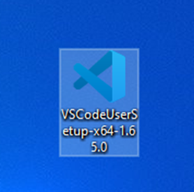

**Figure 3**

**Step 4:** Click on the installer icon to start the installation process of the Visual Studio Code.

**Step 5:** After the Installer opens, it will ask you for accepting the terms and conditions of the Visual Studio Code. Click on **I accept the agreement** and then clickthe **Next** button.

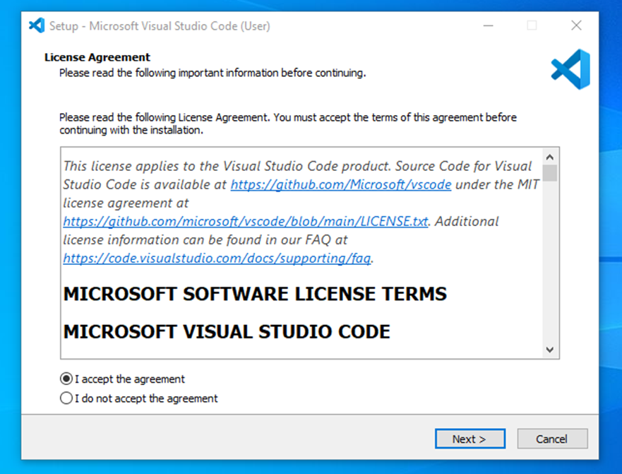

**Figure 4**

**Step 6:** Choose the location data for running the Visual Studio Code. It will then ask you to browse the location. Then click on the **Next** button.

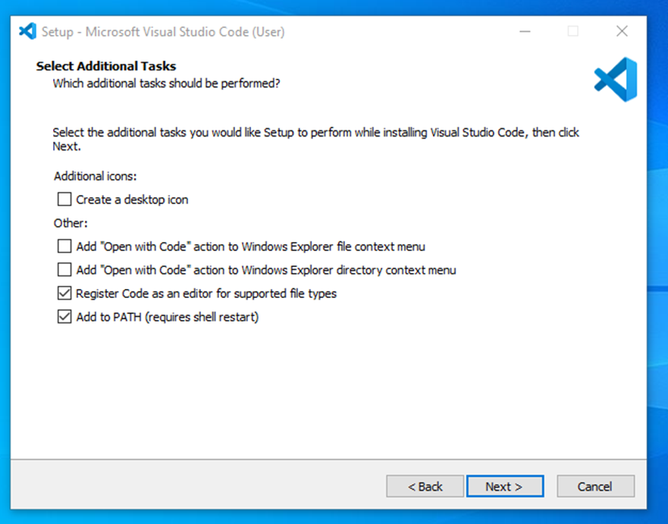

**Figure 5**

**Step 7:** Then it will ask for the installing setup. Click on the **Install** button.

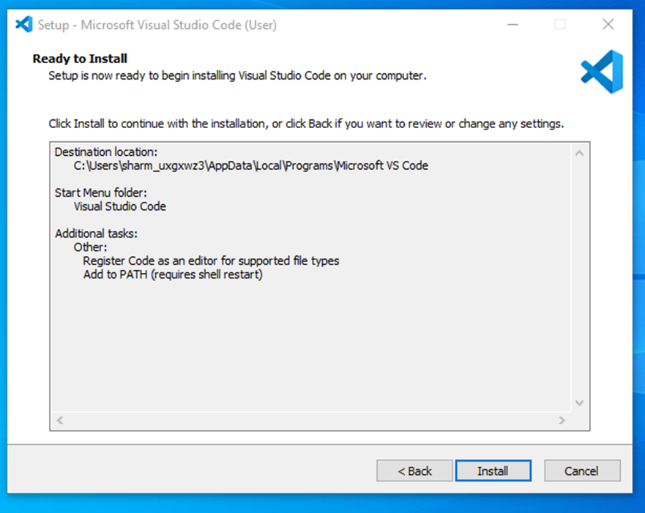

**Figure 6**

**Step 8:** After clicking on Install, it will take about 1 minute to install the Visual Studio Code on your device.

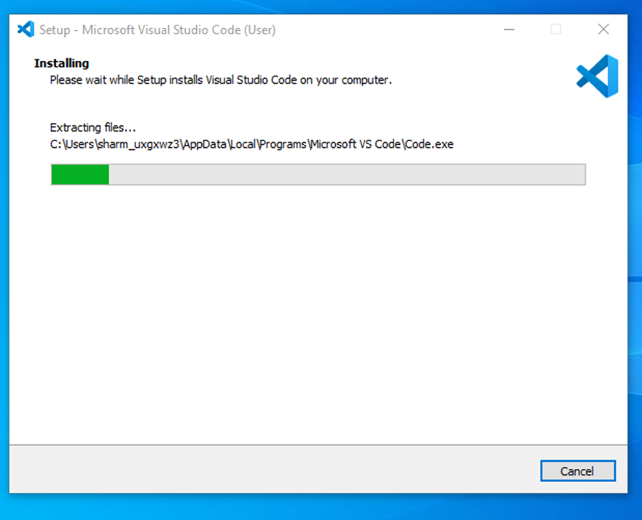

**Figure 7**

**Step 9:** After the Installation setup for Visual Studio Code is finished, it will show a window like this below. Tick the “**Launch Visual Studio Code**” checkbox and then click **Next**.

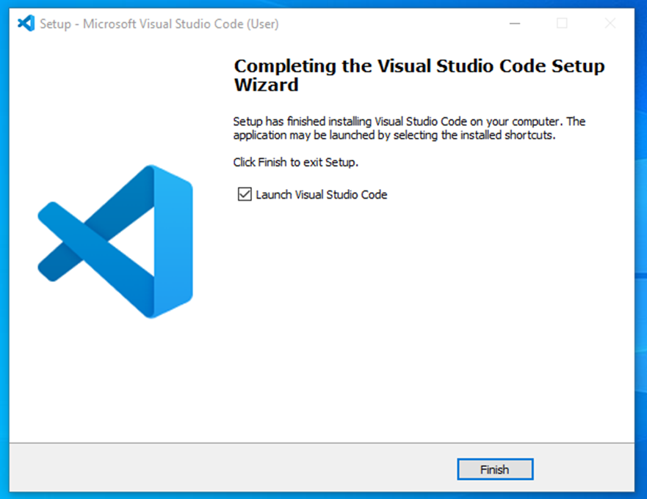

**Figure  8**

**Step 10:** After the previous step, the **Visual Studio Code window** opens successfully. Now you can create a new file in the Visual Studio Code window and choose a language of yours to begin your programming journey!

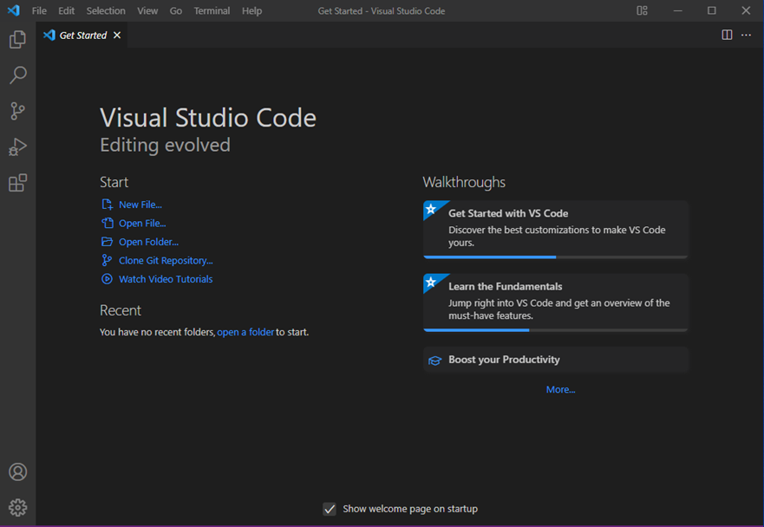

**Figure 9**

So this is how we successfully installed **Visual Studio Code** on our Windows system.

**Database:** MySQL

Selecting a database management system (DBMS) is a critical decision for any software project, and MySQL is often a preferred choice for various reasons:

1. **Popular and stable:**

MySQL is renowned for its popularity and widespread adoption. It has been utilized in countless projects, both large and small, across different industries. Its prevalence in the software development landscape is a testament to its reliability and utility.

MySQL has a proven track record for stability and reliability. It has undergone extensive testing in real-world applications, earning a reputation for being a robust and dependable DBMS. This is crucial for mission-critical systems where data integrity and system uptime are paramount.

1. **Diverse community and documentation:**

MySQL boasts a large and diverse community of users, developers, and contributors. This vibrant community actively supports the platform, continually improving it and addressing issues. This means that you have access to a wealth of knowledge, support, and resources.

MySQL offers comprehensive documentation, tutorials, and resources. This wealth of information simplifies problem-solving and helps users quickly find solutions to specific questions or challenges. The availability of extensive documentation facilitates the learning process and ongoing development with MySQL.

1. **Support for multiple applications:**

MySQL is highly versatile, offering support for multiple programming languages and platforms. This flexibility allows developers to seamlessly integrate it into various applications, regardless of the technology stack being used. Whether you're building a web application with PHP, a mobile app with Java, or a desktop application with Python, MySQL can be integrated effectively.

**Installation Process**

Let's get straight to the point. Installing MySQL on Windows is a very easy but long process. In this article, we'll follow step-by-step how to do it using the MySQL installer, which is the recommended method by the database documentation.

First of all, you need to download the installer. Click [here](https://dev.mysql.com/downloads/installer/), choose the version compatible with your operating system (32-bit or 64-bit), and hit **Download**. Notice that you can also choose the web installer or offline installer. The last one is much heavier while the first will be faster to download.

 When you try to start the download, the website will ask you to log in or create an account, but you don't have to do so. Note the **No thanks, just start my download** button.

When you open the installer, it will first configure the installation and then ask for the user's permission to proceed:

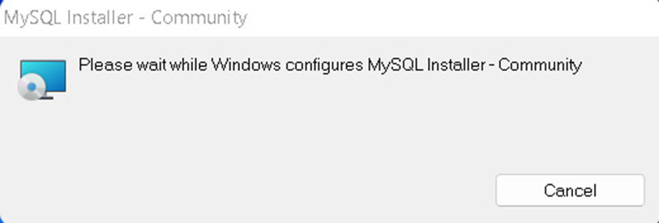

**Figure 10**

When this is over, we'll finally see the installer interface. As you can see in the image below, the process consists of four steps:

1.    Choosing a setup type

1. Downloading the files
2. Installing the software
3. Finishing the installation

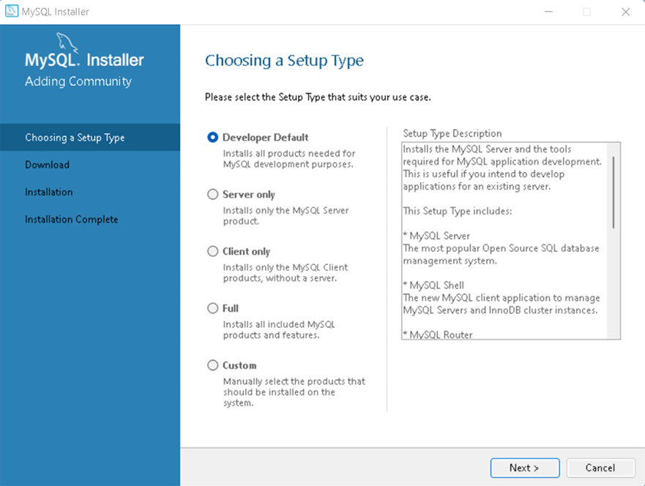

**Figure 11**

There are five types of setups available in this first step and you can check the side box to see what each of them will install. However, we strongly recommend, especially if you're just getting started with SQL, to select the default option.

The most important features, among others, this setup will install are:

* MySQL Server: the database server itself
* MySQL Workbench: an application to manage the server
* MySQL for Visual Studio: this feature enables the users to use MySQL from Visual Studio
* The documentation and tutorials

It's also ok to choose the full setup as this will install all MySQL resources available.

After you choose the setup option, click **Next**.

**Requirements**

At this point, there's a chance you'll be asked to install some required software, the most common being the Visual Code. The installer can automatically solve some requirement issues, however, this is not the case here:

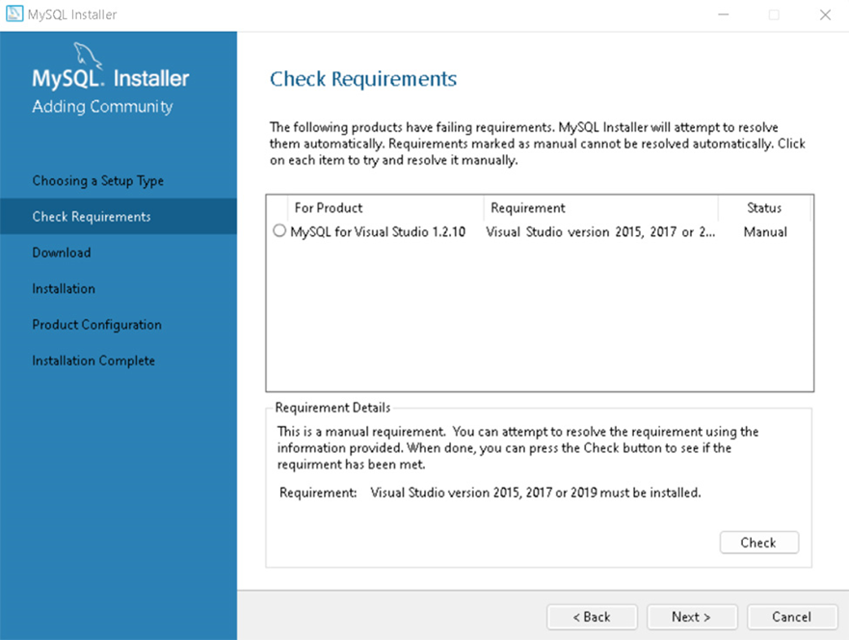

**Figure 12**

If you run into this, you can find one of the required versions of Visual Code [here](https://visualstudio.microsoft.com/pt-br/vs/older-downloads/). This issue won't stop from proceeding with the installation, though.

**Download & Install**

You have now reached the download section. The section name is self-explanatory: you'll download all the components in the setup option you selected.

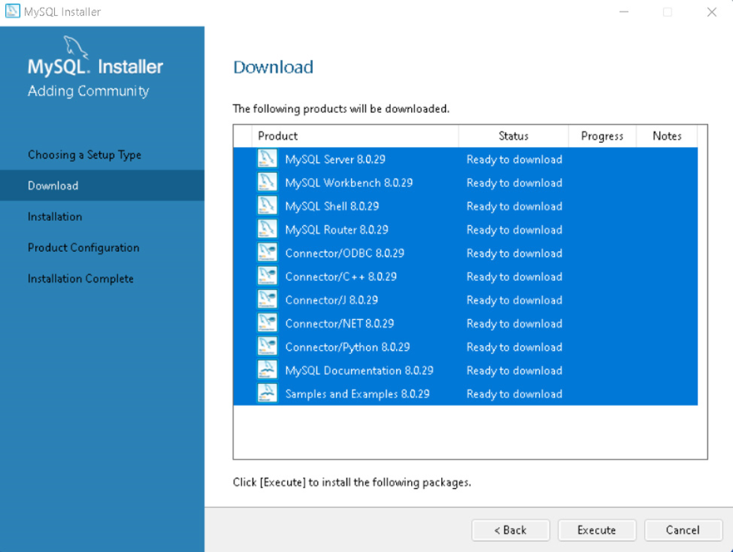

**Figure 13**

Click on **Execute** and the download will start. This might take a few minutes to be concluded.

When it's done, you should see tick marks on every item. Then you can proceed.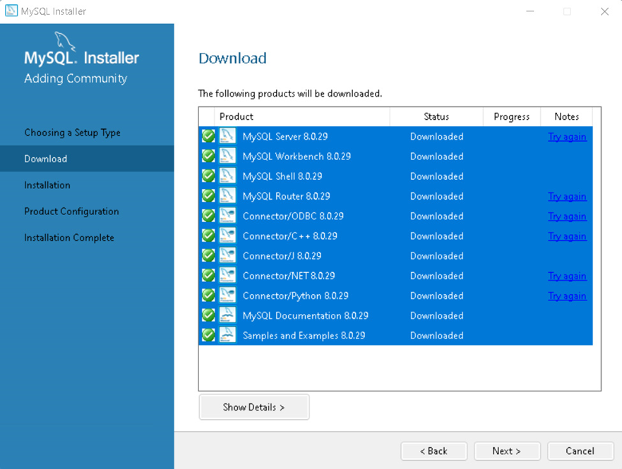

**Figure 14**

The next screen you'll see is almost the same as the last one, but now it will install all the components you've just downloaded. This step will take significantly longer than the previous one.

When it's over, you'll see all the ticks marks again:

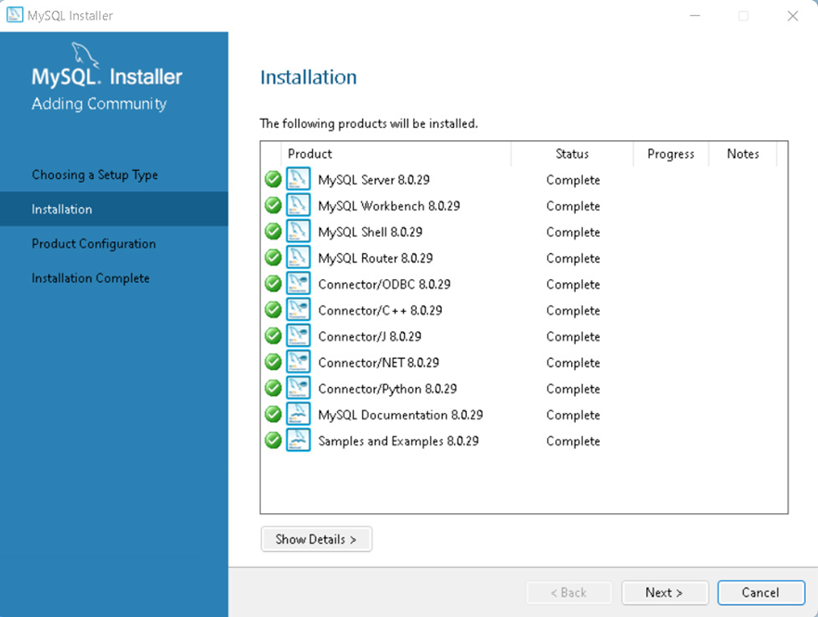

**Figure 15**

**Configuration**

The next step is to configure the server. You'll see the following screen. Hit **Next**.

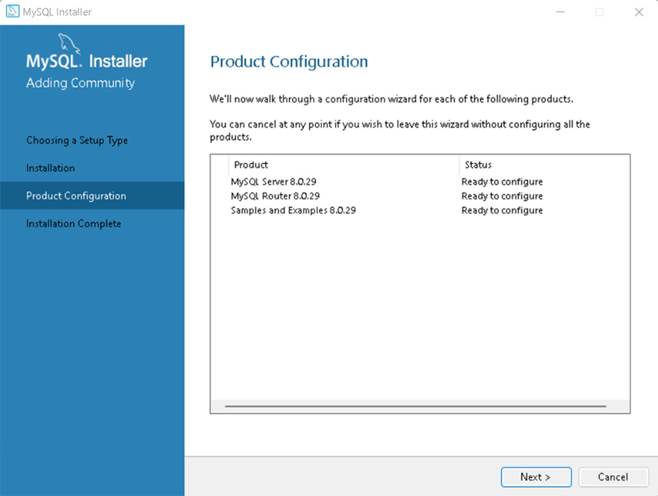

**Figure 16**

First, the installer will ask you to configure the network: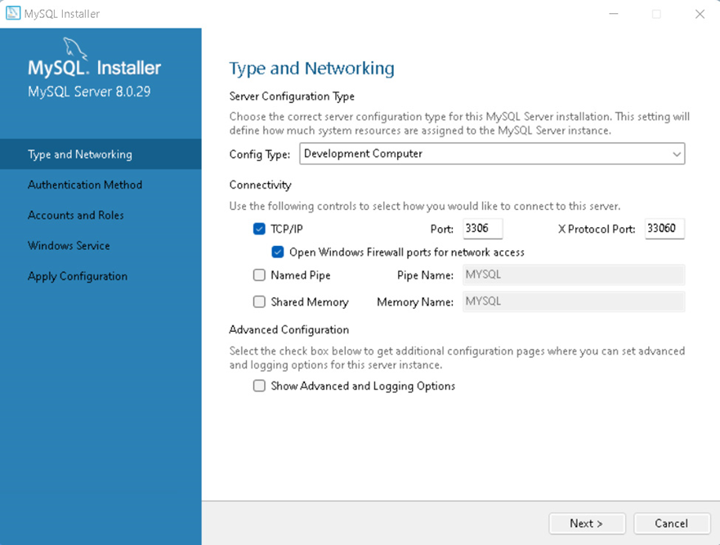

**Figure17**

It's important to keep *Development Computer* in the *Config Type* field as you're probably installing this on your personal computer and not on a dedicated machine. You can choose the port, but the default will work just fine. Click **Next**.

For the authentication method, let's stick with the recommended option and click **Next**:

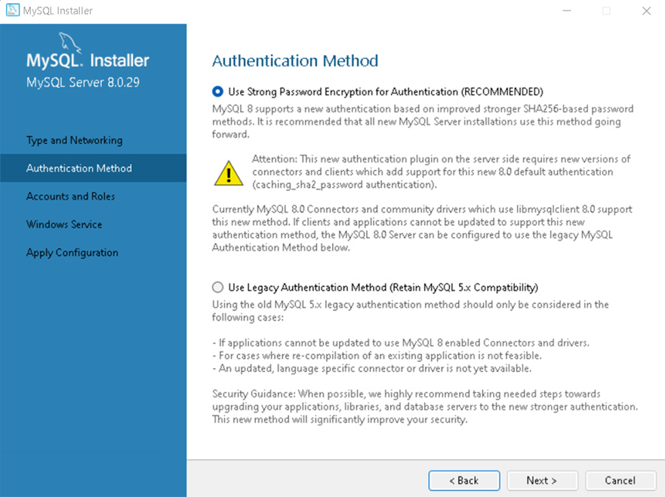

**Figure 18**

Now it's time to create the root account. You'll be asked to set a password. Remember to use a strong one.

On this same screen, you can create other users and set their passwords and permissions. You just have to click on **Add User** and fill in the blanks. Then, click **Next**.

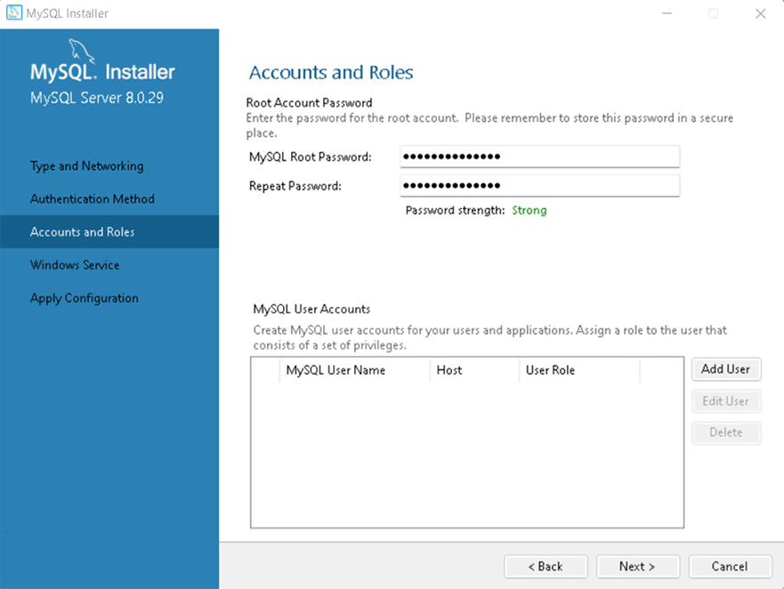

**Figure 19**

Now you can choose the Windows service details, such as the service name, account type, and if you want to start MySQL when you turn on your computer. Again, the default options will work in most cases:

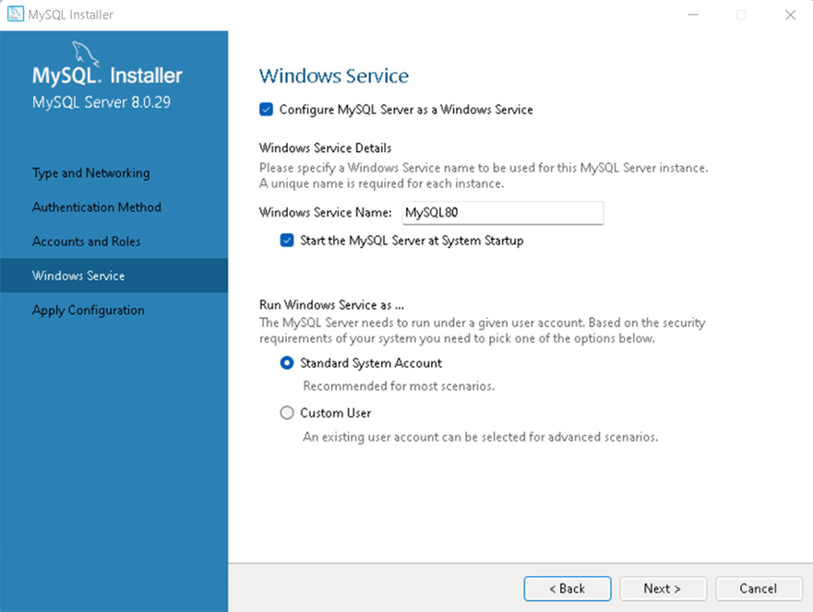

**Figure 20**

The next screen applies the configuration. Execute it. This step also takes a while to be concluded.

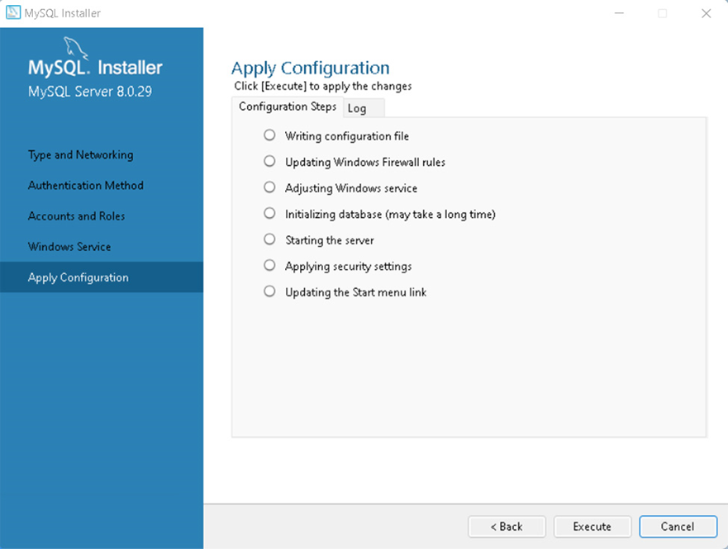

**Figure 21**

After it ends, just finish the process.

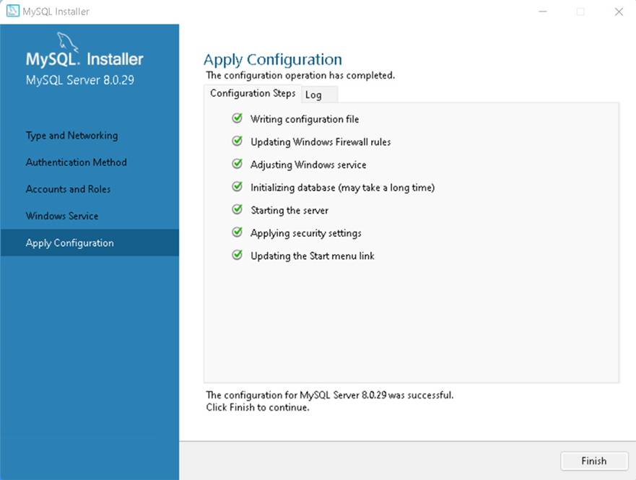

**Figure 22**

**Final Steps**

We're almost there! The next step is to connect to the server. Type the root account's password and click **Check**. You'll see the *Connection succeed* status:

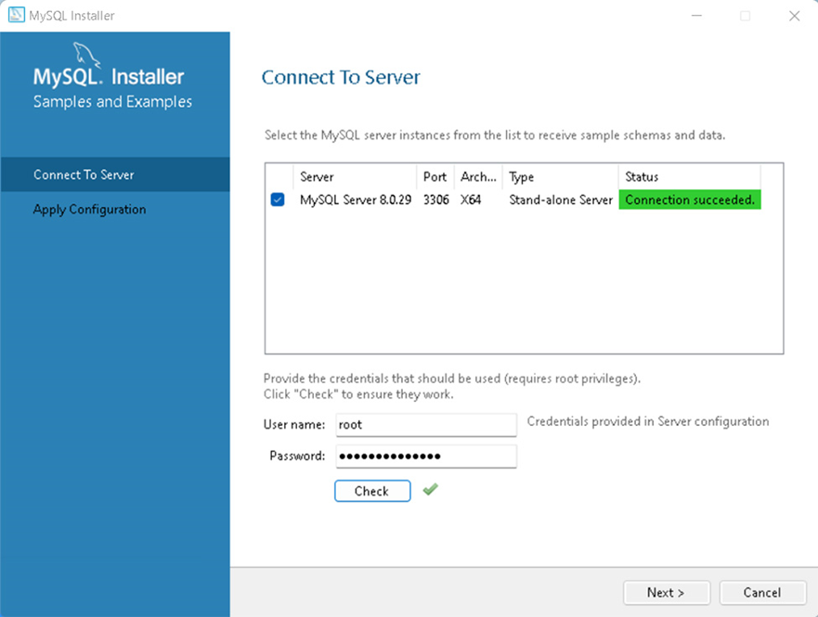

**Figure 23**

This screen is followed by another one asking to apply the configuration. Just execute it and click **Finish**.

We have finally reached the last screen.

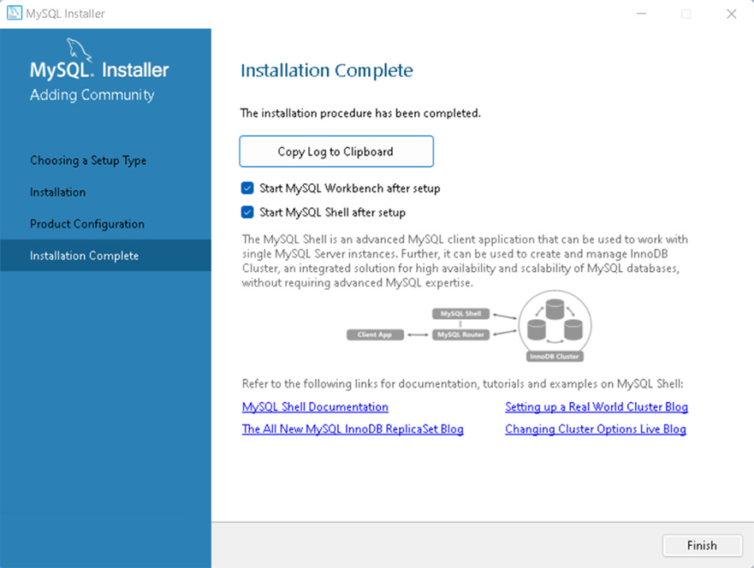

**Figure 24**

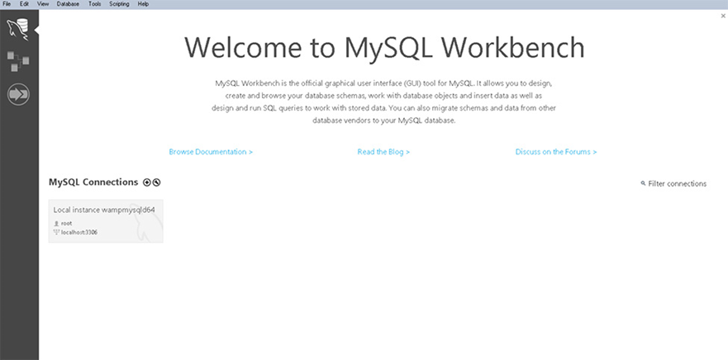

**Figure 25**

**Backend:** Use XAMPP to run PHP.

Choosing XAMPP (which stands for Cross-platform, Apache, MySQL, PHP, and Perl) as your development environment offers several compelling advantages, making it a preferred option for many developers:

1. **User-friendly**: XAMPP is designed to be user-friendly and straightforward, making it exceptionally easy to install and use. It offers an integrated package that includes essential components like Apache (the web server), MySQL (the database management system), PHP, and other related tools. This integrated environment minimizes the complexity associated with setting up a development environment, enabling individuals with varying levels of technical expertise to establish a local development server swiftly and effortlessly.

1. **Cross-platform compatibility:** XAMPP's cross-platform compatibility is a significant advantage. It is available for various operating systems, including Windows, macOS, and Linux. This compatibility ensures that developers can work with XAMPP on their preferred platform without any constraints. It also simplifies collaborative development across diverse environments.

1. **Web Application Development:** XAMPP serves as an invaluable tool for web application development. It allows developers to create, test, and refine PHP web applications and MySQL databases on their personal computers. This local development environment is ideal for ironing out issues, conducting testing, and experimenting with changes in a controlled setting. It mitigates the risks associated with deploying untested code directly to a live server, ensuring a smoother and more reliable transition to production.

**Installing XAMPP**

**Step 1**: Download

XAMPP is a release made available by the non-profit project Apache Friends. Versions with PHP 5.5, 5.6, or 7 are available for download on the [Apache Friends](http://www.apachefriends.org/de/download.html) website.

**Step 2:** Run .exe file

Once the software bundle has been downloaded, you can start the installation by double clicking on the file with the ending [.exe](https://www.ionos.com/digitalguide/server/know-how/exe-file/).

**Step 3:** Deactivate any antivirus software

Since an active antivirus program can negatively affect the installation process, it’s recommended to temporarily pause any antivirus software until all XAMPP components have successfully been installed.

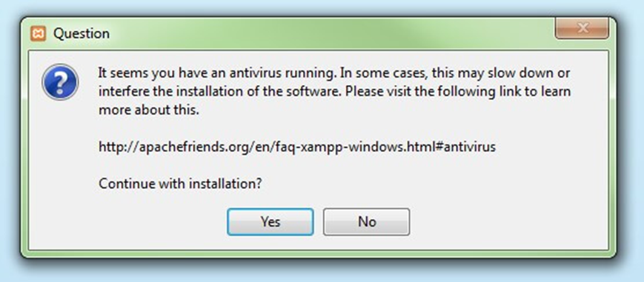

**Figure 26**

Before installing XAMPP, it is advisable to disable the anti-virus program temporarily

**Step 4:** Deactivate UAC

User Account Control (UAC) can interfere with the XAMPP installation because it limits writing access to the C: drive, so we recommend you deactivate this too for the duration of the installation process. To find out how to turn off your UAC, head to the [Microsoft Windows support pages](https://support.microsoft.com/en-us/help/17228/windows-protect-my-pc-from-viruses).

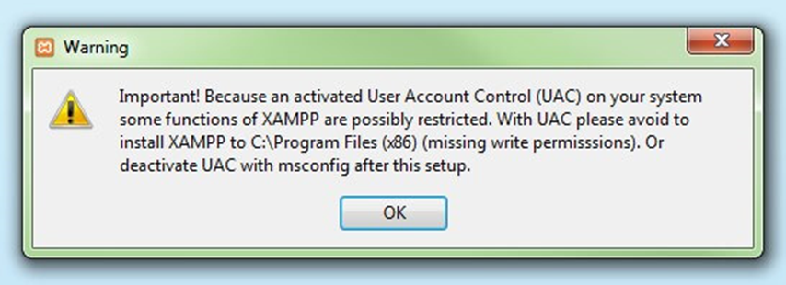

**Figure 27**

User account control can affect the installation of XAMPP

**Step 5:** Start the setup wizard

After you’ve opened the .exe file (after deactivating your antivirus program(s) and taken note of the User Account Control, the start screen of the XAMPP setup wizard should appear automatically. Click on ‘Next’ to configure the installation settings.

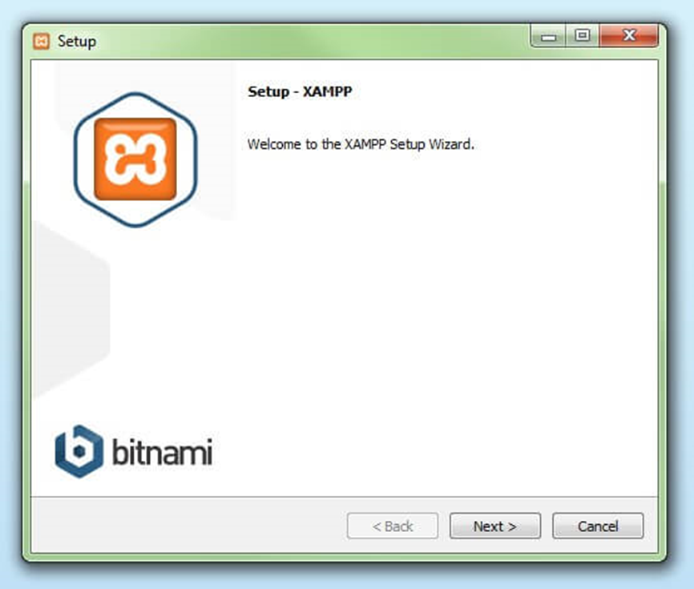

**Figure 28**

     You can start the setup on the startup screen

**Step 6:** Choose software components

Under ‘Select Components’, you have the option to exclude individual components of the XAMPP software bundle from the installation. But for a full local test server, we recommend you install using the standard setup and all available components. After making your choice, click ‘Next’.

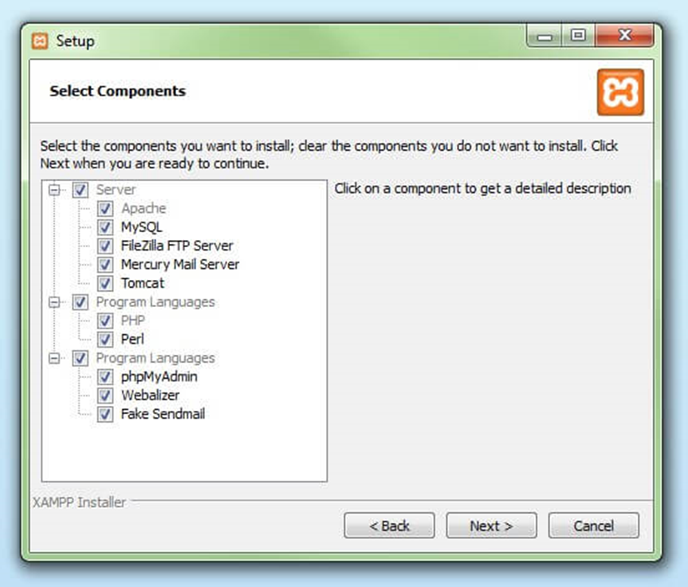

**Figure 29**

In the dialog window entitled 'select components', you can choose the software components before installation

**Step 7:** Choose the installation directory

In this next step, you have the chance to choose where you’d like the XAMPP software packet to be installed. If you opt for the standard setup, then a folder with the name XAMPP will be created under C:\ for you. After you’ve chosen a location, click ‘Next’.

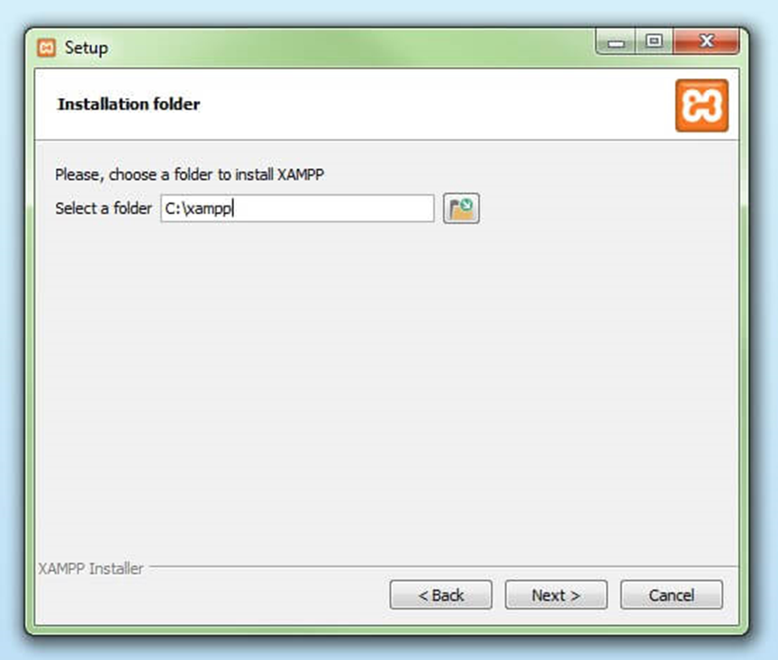

**Figure 30**

For the next step, you need to select the directory where XAMPP should be installed

**Step 8:** Start the installation process

Once all the aforementioned preferences have been decided, click to start the installation. The setup wizard will unpack and install the selected components and save them to the designated directory. This process can take several minutes in total. You can follow the progress of this installation by keeping an eye on the green loading bar in the middle of the screen.

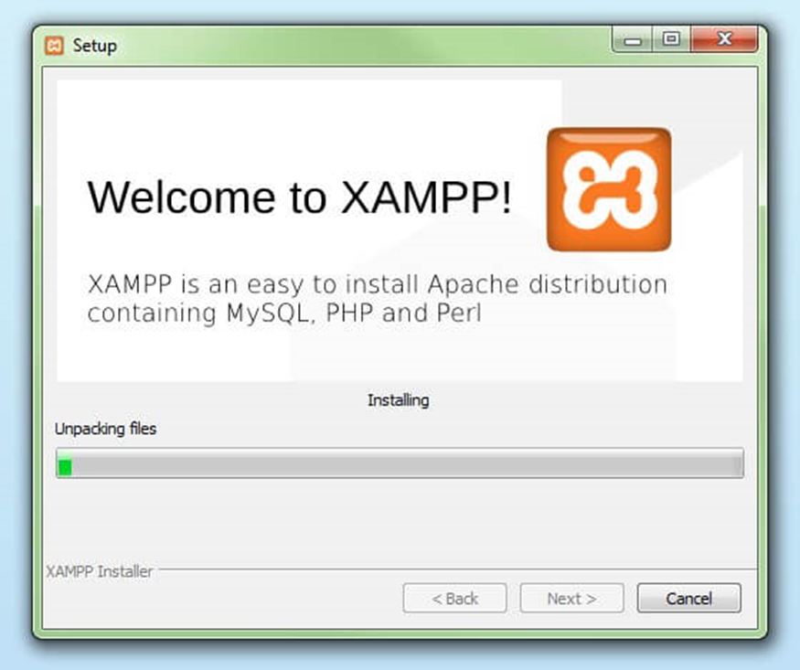

**Figure 31**

According to the default settings, the selected software components are unpacked and installed in the target folder

**Step 9:** Windows Firewall blocking

Your Firewall may interrupt the installation process to block some components of the XAMPP. Use the corresponding check box to enable communication between the Apache server and your private network or work network. Remember that making your XAMPP server available for public networks isn’t recommended.

**Step 10:** Complete installation

Once all the components are unpacked and installed, you can close the setup wizard by clicking on ‘Finish’. Click to tick the corresponding check box and open the XAMPP Control Panel once the installation process is finished.

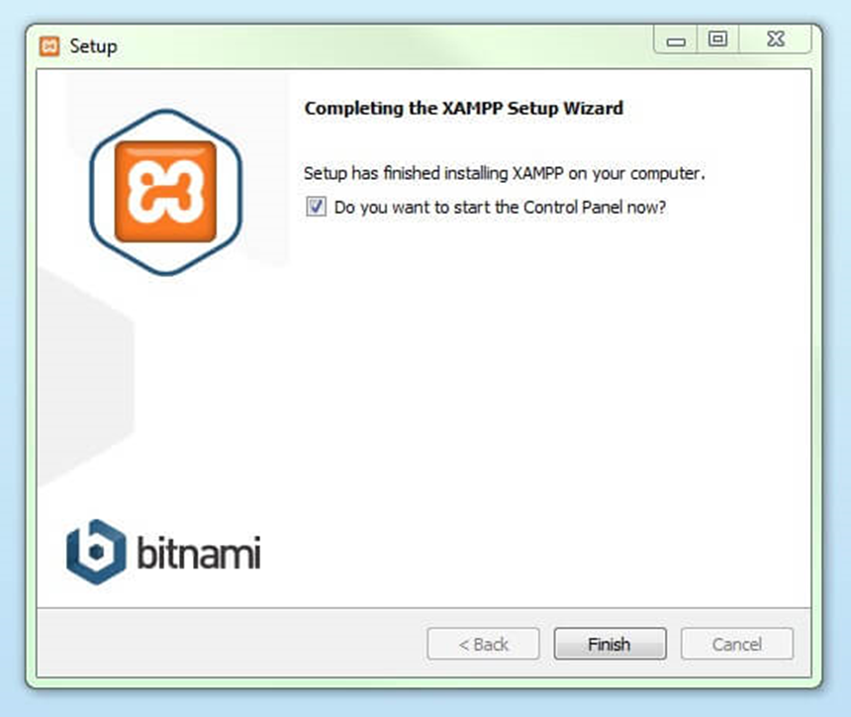

**Figure 32**

By clicking on 'finish', the XAMPP Setup Wizard is completed

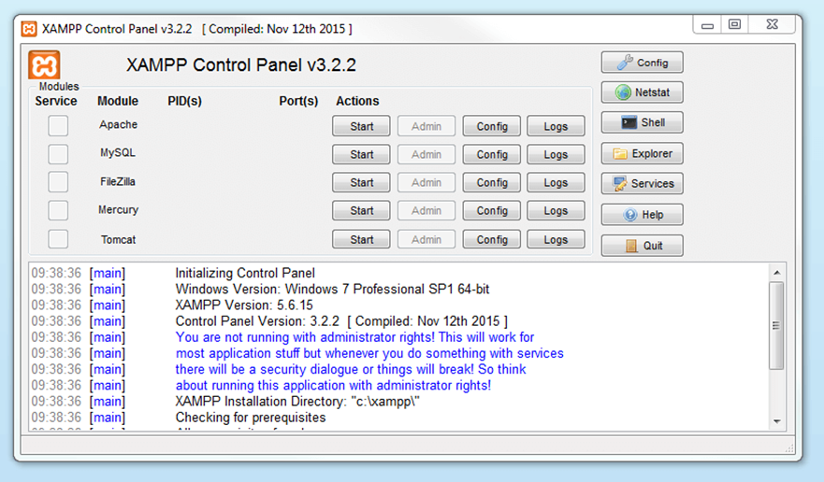

**Figure 33**

The use of Visual Studio Code, MySQL and XAMPP for software development and database management is the smart choice based on their robustness, integration, stability and cross-platform support and can maximize performance.

**Minimum configuration requirements for Visual Studio Code:**

* **Operating system:** VSC supports Windows, macOS and Linux. So, you can use VSC on most popular operating systems. Specific configuration requirements depend on the operating system you are using.
* **RAM:** At least 4GB of RAM, however, if you work on large projects or use a lot of extensions, you should consider using a computer with 8GB or more of RAM.

**Minimum configuration requirements for MySQL:**

* **Operating System:** MySQL also supports Windows, macOS, and Linux. Specific configuration requirements depend on the operating system.
* **RAM:** MySQL Server requires at least 4GB of RAM to function basically. However, the more RAM the better, especially if you are working with large databases or multi-user projects.
* **Processor:** MySQL works on most processors, but multi-core processors will improve performance when you have multiple users accessing it simultaneously.

**Minimum configuration requirements for XAMPP:**

XAMPP is also a cross-platform application, and requires the same configuration as for MySQL and Apache. Here are the minimum requirements:

* **Operating system:** XAMPP supports Windows, macOS, and Linux.
* **RAM:** Similar to MySQL, at least 512MB of RAM is necessary, but you should consider using a computer with 2GB or more of RAM to ensure good performance.

# Processor: Multi-core processors will help improve XAMPP performance as you develop and test web applications.

# Customer Requirements Specification

## Users of the System

## System functions

* 1. **Register – Login – Logout:**
     1. **Register:**

**Step 1:** First, click on the human icon and then the login/ register page will appear and we continue to click register when we do not have an account

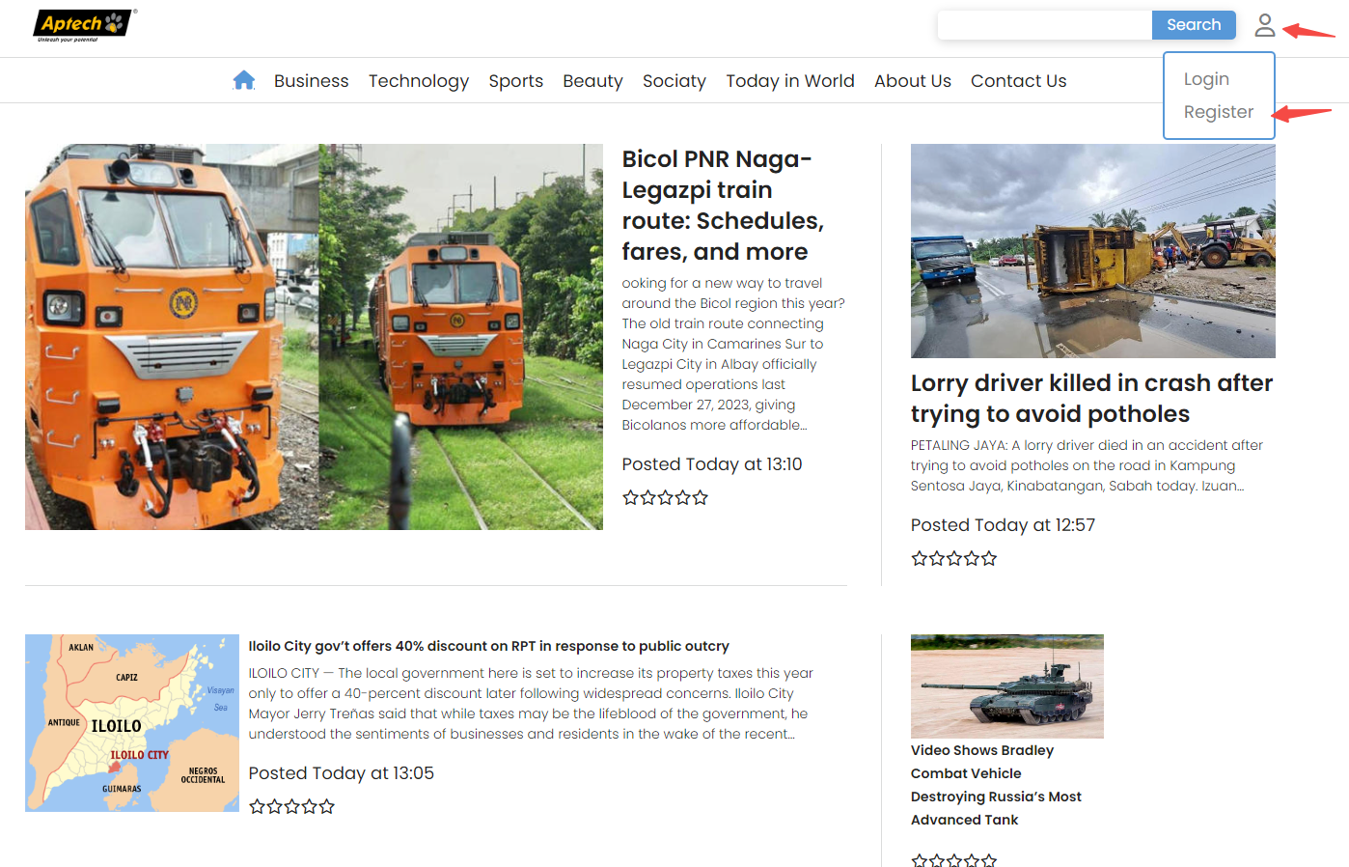

**Step 2:** After we have entered the registration page , fill in the necessary information to create an account.

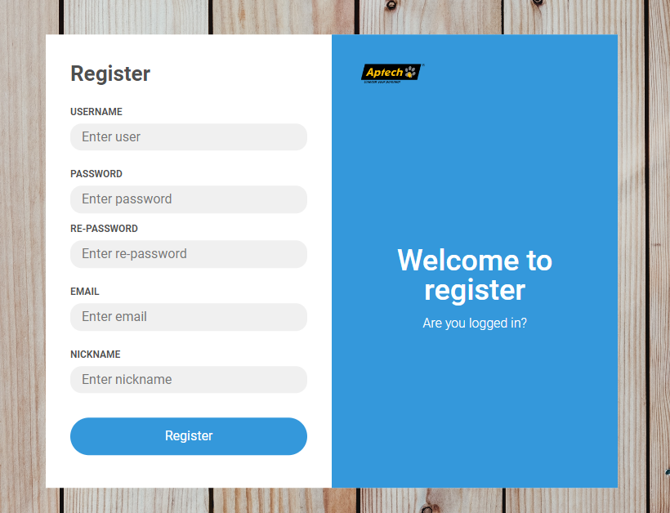

**Step 3:** Verify information

Once registration is complete, the system conducts a validation check to evaluate the conformity of all input values with the specified validation criteria. In case any input value does not meet the standards, the system will quickly notify errors.

Specifically, it will check whether the provided username, email, nickname, is already exist in the database or not. It’s will raise error via message box.

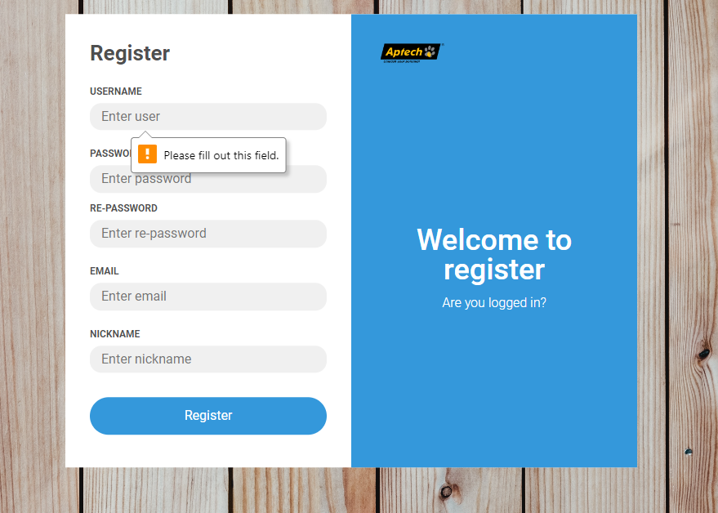

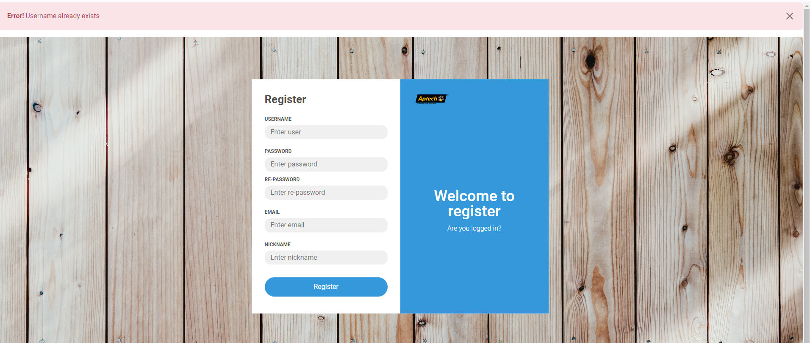

After the user has met all the requirements from the registration form, the system will notify you that you have successfully registered.

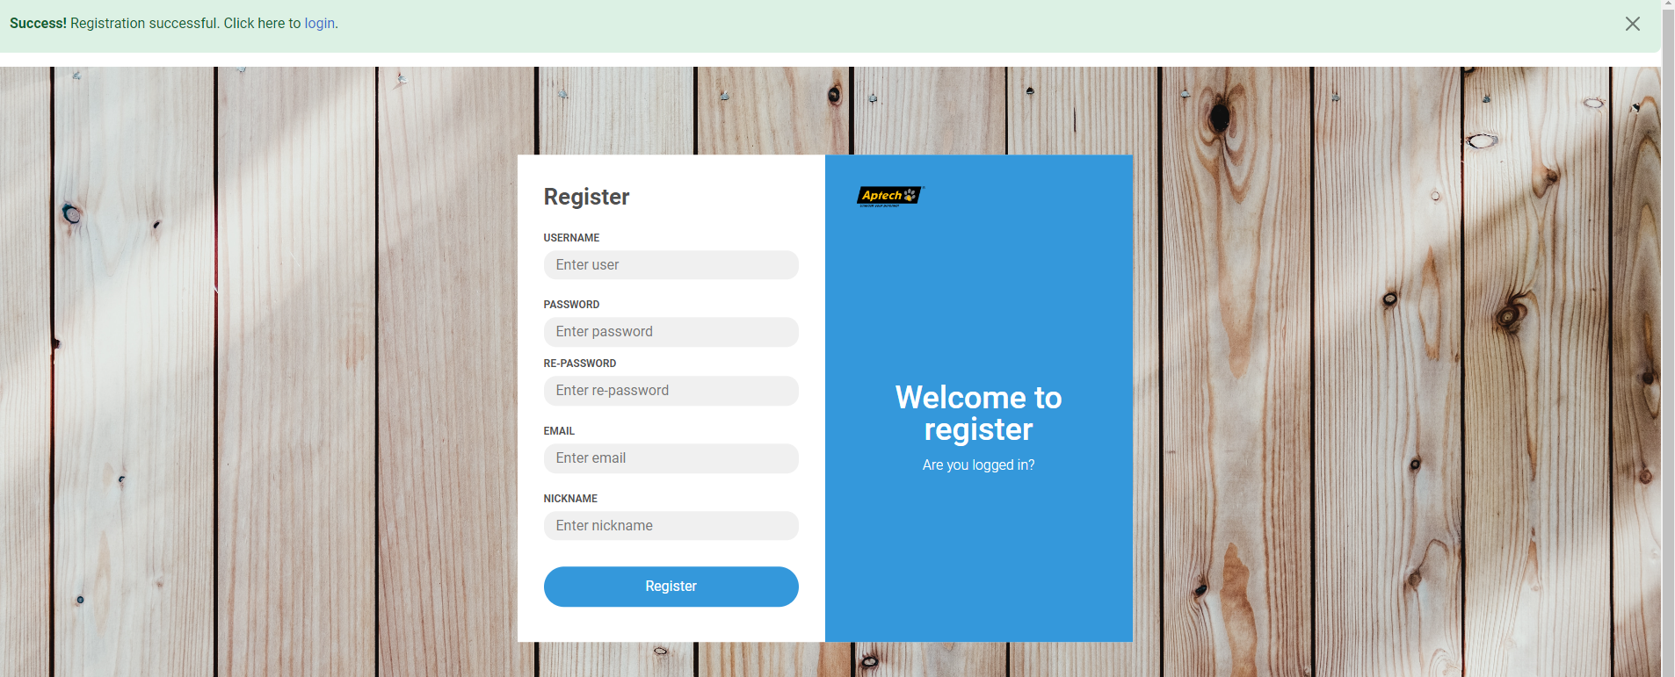

**Input:** User registers at the registrations form

**Output:** The user successfully registered and will return to the login page to log in to the website.

**Processing method:** Check regular expressions, verify email, do not duplicated username, email, nickname.

**Stored data:** User information data in the user’s table in the database

* + 1. **Login Function:**

**Step 1:** Click on the human icon and click Login line

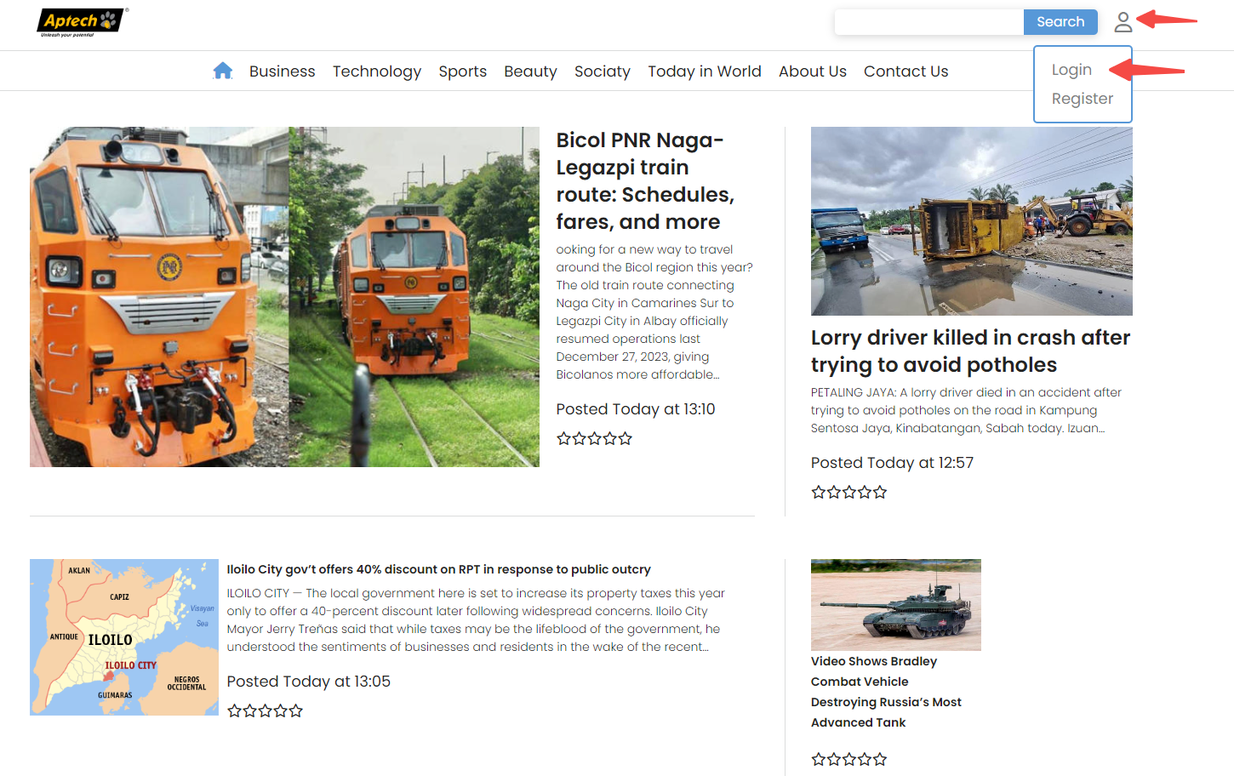

**Step 2:** Fill username and password

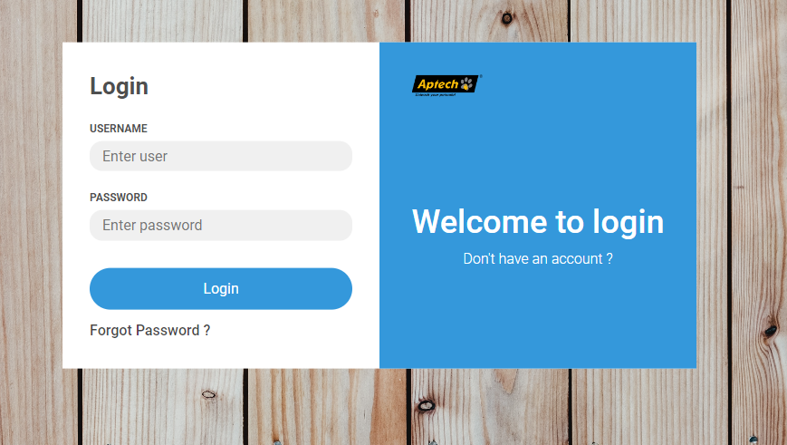

**Step 3: Information Validation:**

* If username and password are blanked, it’s will raise error.
* Wrong password or wrong username  
    
  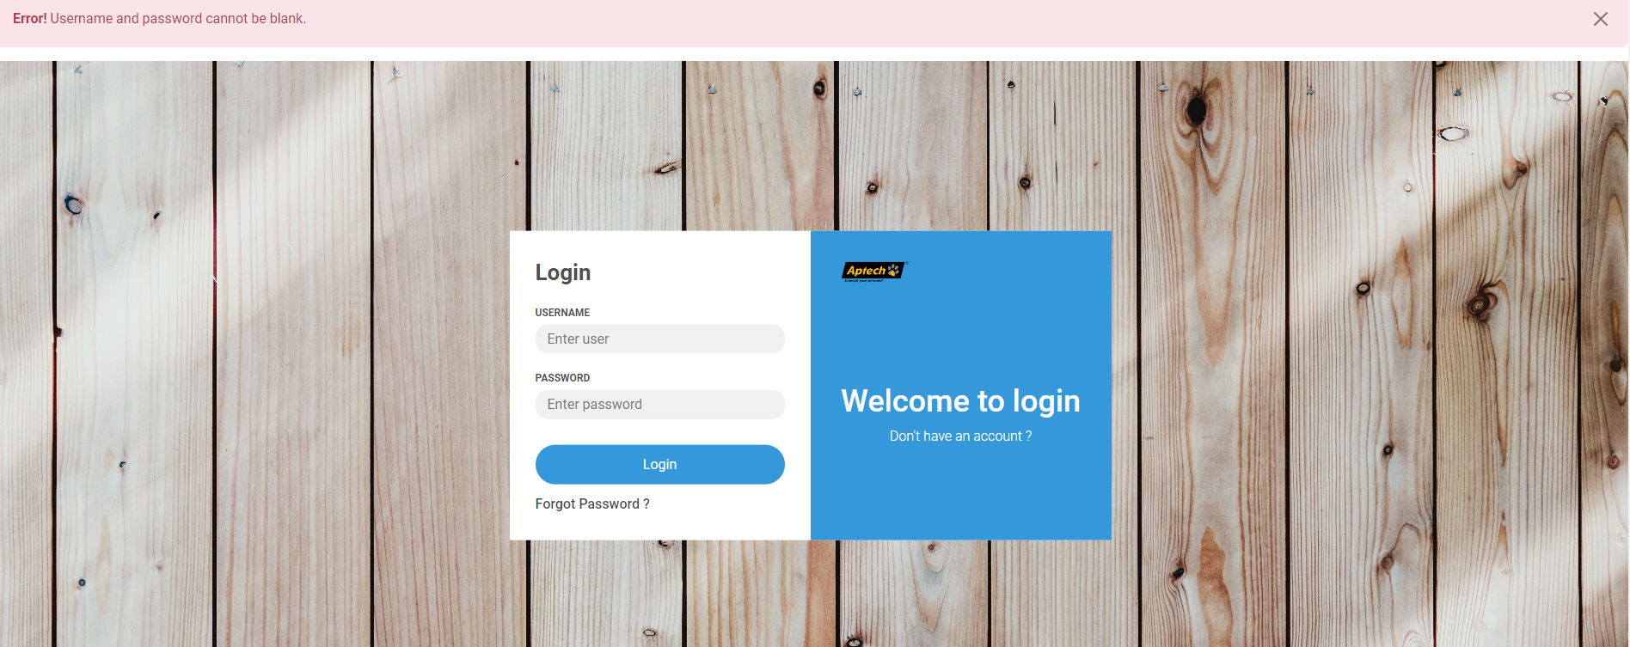

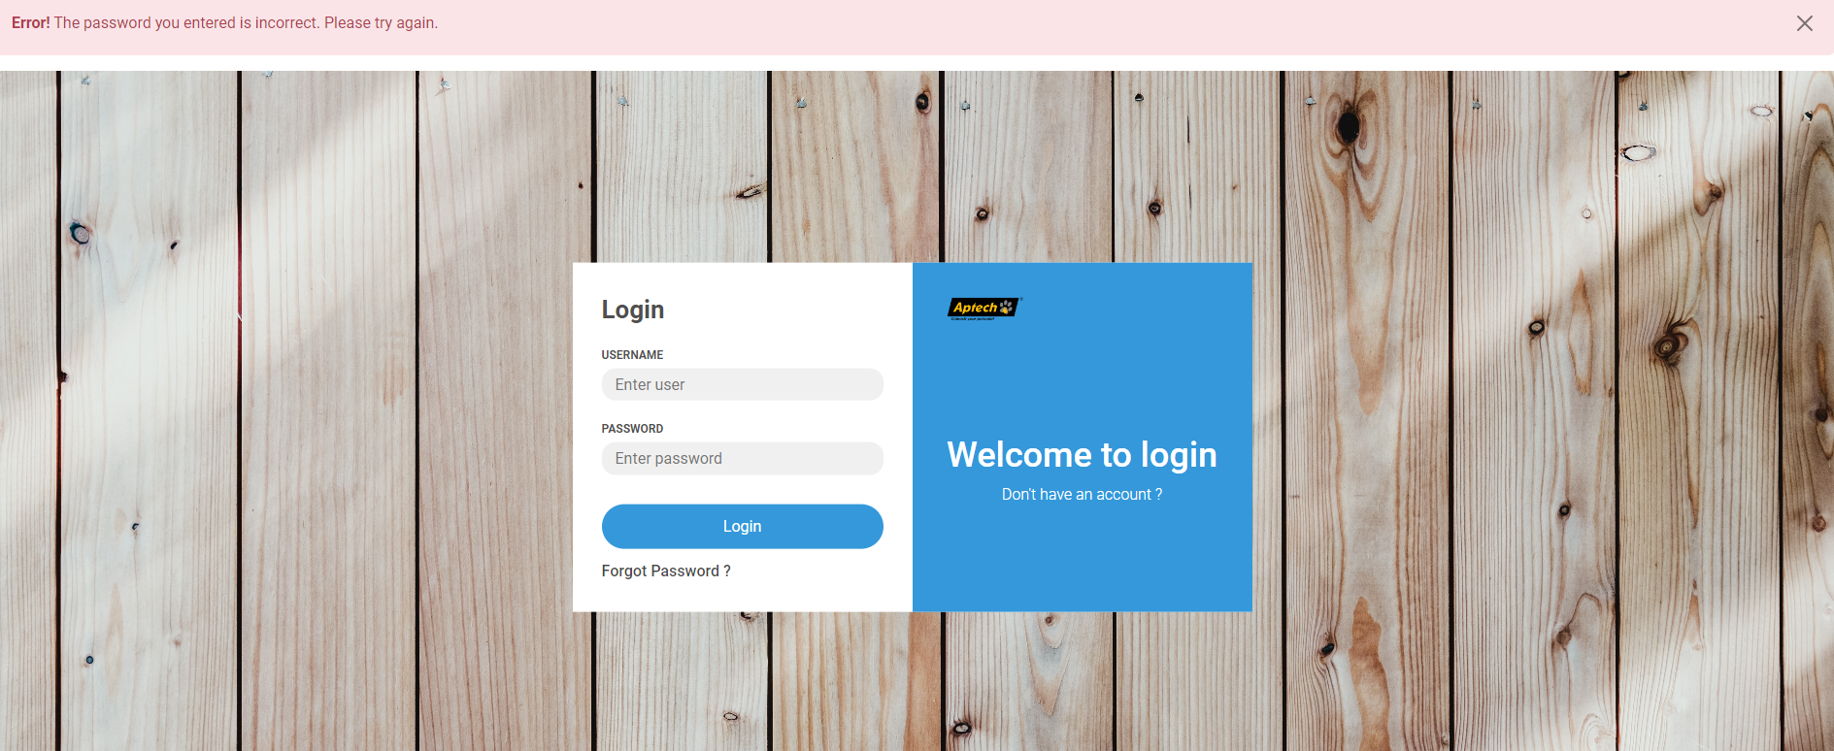

**Input:** The user logs in at the log-in panel.

**Output:** The user successfully logs in.

**Processing methods:** Check the information in the database

**Stored data:** SESSION data

* + 1. **Log out Function:**

**Step 1:** Click on the human icon and click Log out line

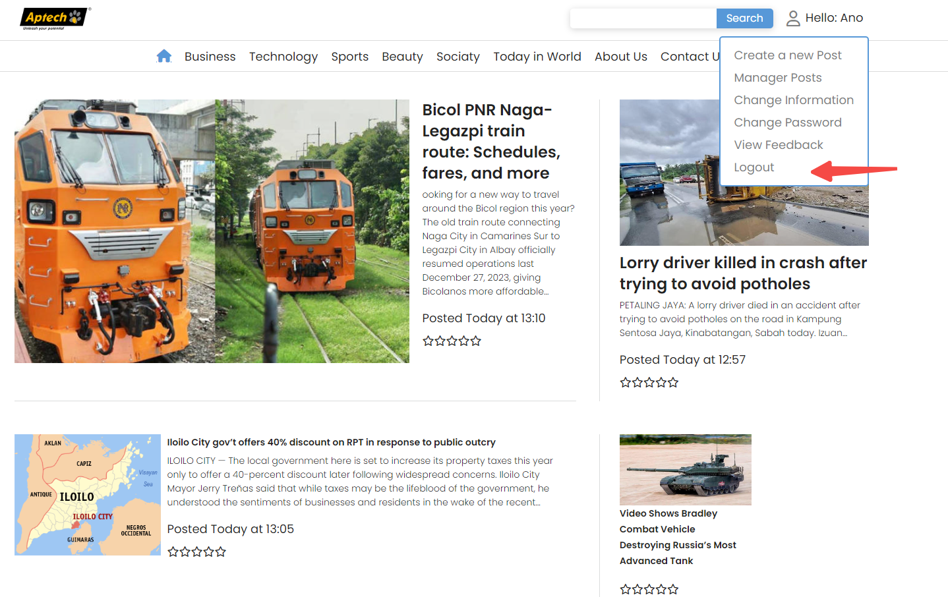

**Input:** The user logs out at the home page

**Output:** The user successfully logs out.

**Processing methods:** Clear the session of the account

**Stored data:** SESSION data

* 1. **Feedback Function**

Here when the user accesses the Contact Us page to be able to send feedback, the user is required to log in first.

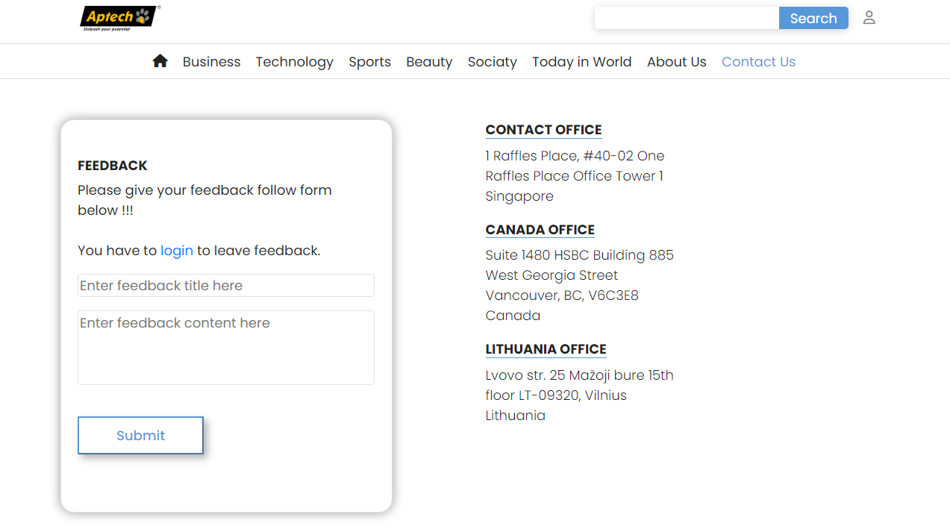

Once logged in, the user will be allowed to send feedback. User can review their feedback, response from admin either in view feedback.

**Input:** The user logs out at the home page

**Output:** The user successfully logs out.

**Processing methods:** Clear the session of the account

**Stored data:** SESSION data

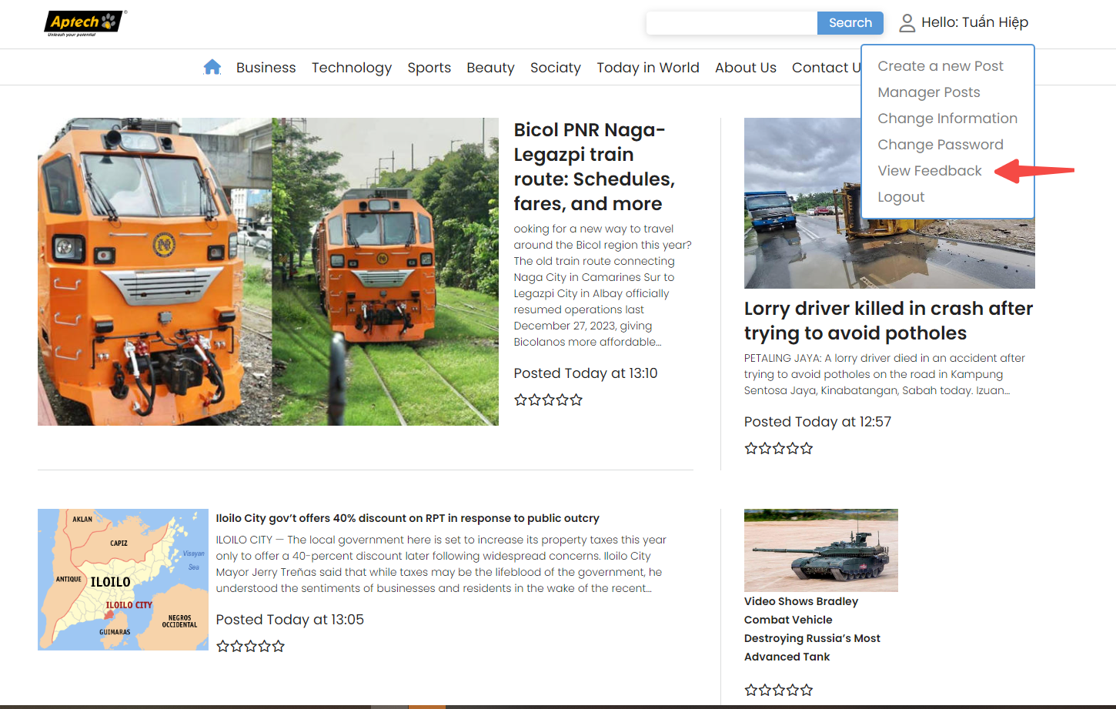

**Input:** Feedback title and feedback content both are being written by the user.

**Output:** Displayed on the home page.

**Processing Method:** User enter information related feedback into fields on the website. After users have completed the input, they press “Submit”. The system checks the information and feedback content, then display it.

**Stored data:** in the feedback table

* 1. **Create a new Post**

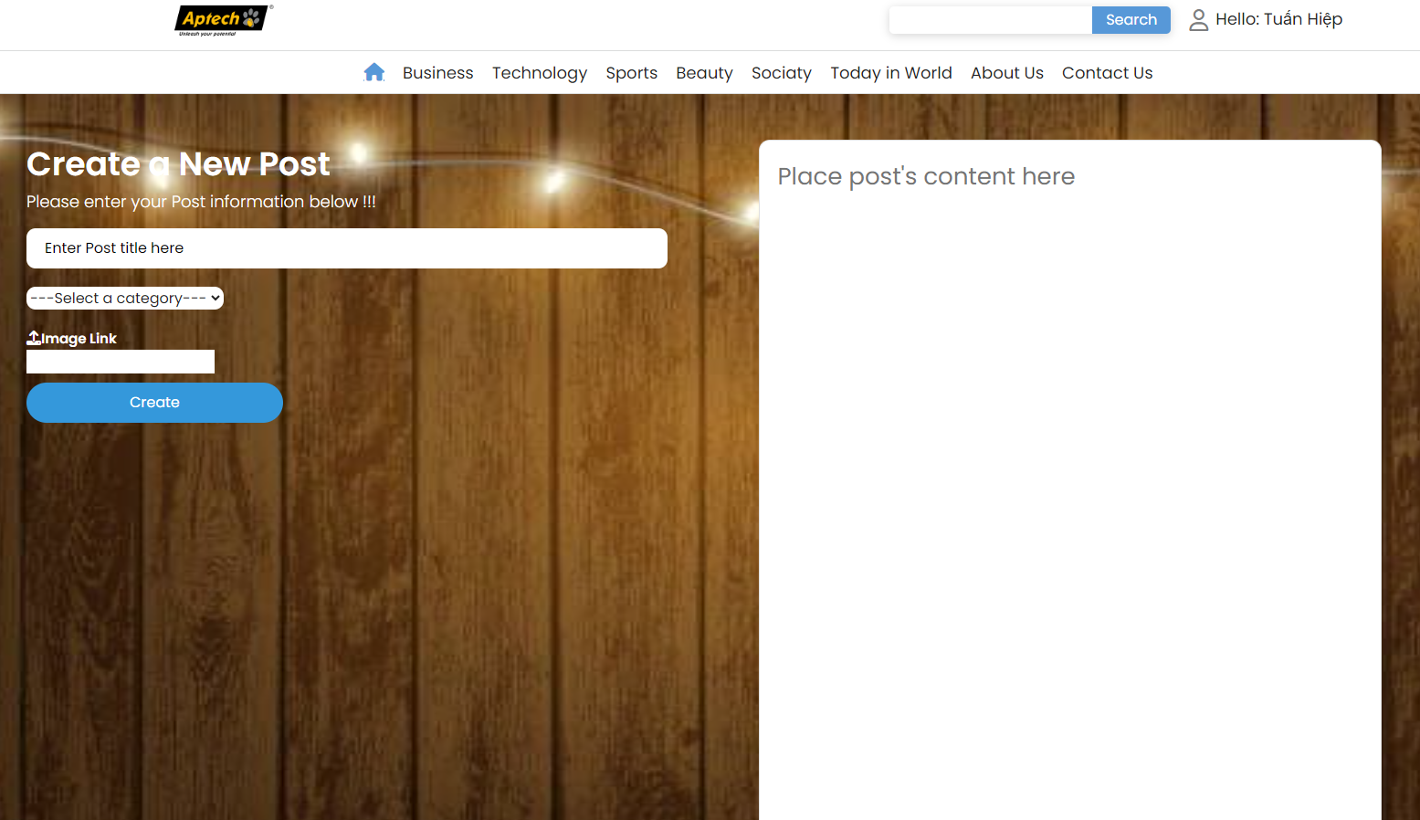

**Input:** title, content, image, category will be filled by the user.

**Output:** Displayed on the home page.

**Processing Method:** User enter information related post into fields. After users have completed the input, they press “Create”. Raise message box after submit form

* Successfully, when information is valid
* Error, when information is invalid

**Stored data:** in the post table

* 1. **Change user information**

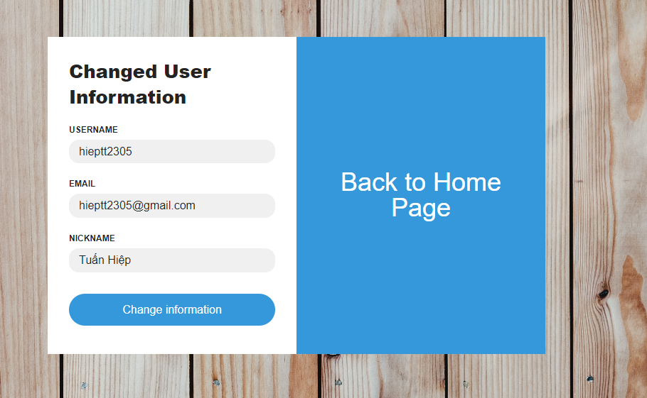

**Input:** username, email, nickname will be filled by the user.

**Output:** Displayed on the change information page.

**Processing Method:** User enter information related post into fields. After users have completed the input, they press “Change information”. Raise message box after submit form

* Successfully, when information is valid
* Error, when information is invalid

**Stored data:** in the user table

* 1. **Change Password**

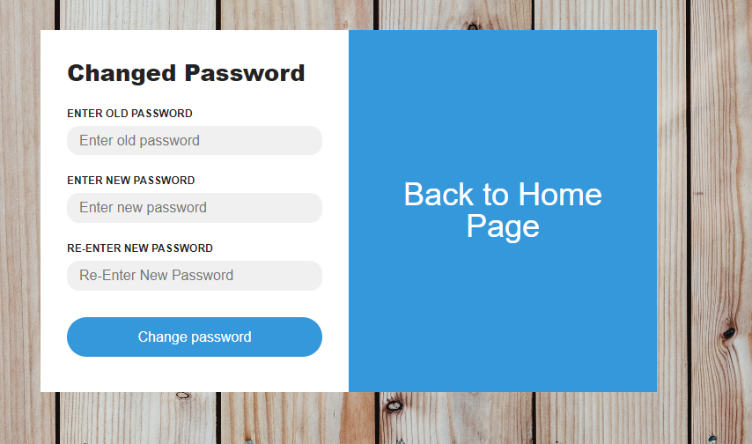

**Input:** old password, new password, re-enter new password will be filled by the user.

**Output:** Displayed on the change password page.

**Processing Method:** User enter information related post into fields. After users have completed the input, they press “Change password”. Raise message box after submit form

* Successfully, when information is valid
* Error, when information is invalid

**Stored data:** in the user table

# System Designs

## Entity Relationship Diagram

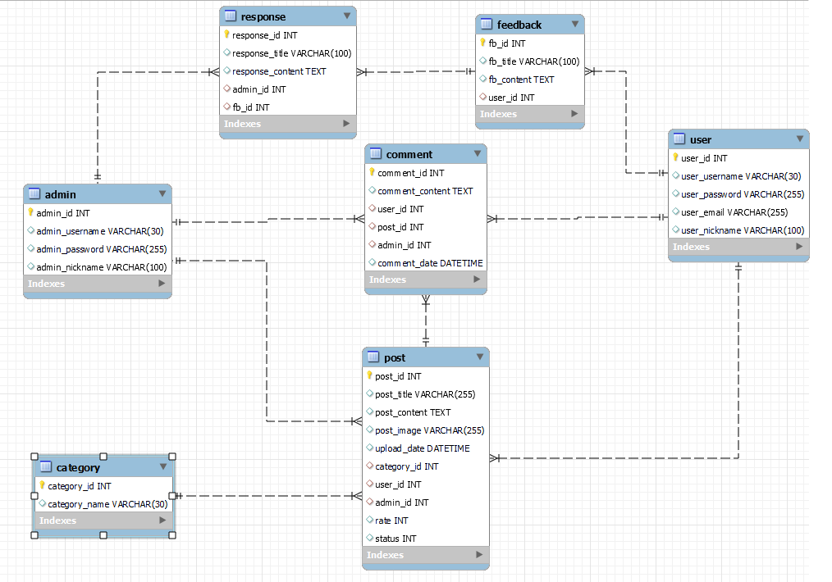

## Database Design

The News Reporter database have 7 tables:

* Admin
* User
* Category
* Post
* Comment
* Feedback
* Response

**The Relationship between tables in the database:**

|  |  |  |
| --- | --- | --- |
| **Table Name** | **Table Name** | **Relationship** |
| Admin | Post | One-to-many |
| Comment | One-to-many |
| Response | One-to-many |
| User | Post | One-to-many |
| Comment | One-to-many |
| Feedback | One-to-many |
| Feedback | Response | One-to-many |
| Category | Post | One-to-many |
| Post | Comment | One-to-many |

**Table detail**

1. **Admin:**

|  |  |  |  |  |  |
| --- | --- | --- | --- | --- | --- |
| **Column** | **Data type** | **Constraint** | **Description** | | |
| admin_id | INT | PRIMARY KEY | | AUTO_INCREMENT |
| admin_username | VARCHAR(30) | NOT NULL | |  |
| admin_password | VARCHAR(255) | NOT NULL | |  |
| admin_nickname | NVARCHAR(100) | NOT NULL | |  |

1. **User:**

|  |  |  |  |
| --- | --- | --- | --- |
| **Column** | **Data type** | **Constraint** | **Description** |
| user_id | INT | PRIMARY KEY | AUTO_INCREMENT |
| user_username | VARCHAR(30) | NOT NULL |  |
| user_password | VARCHAR(255) | NOT NULL |  |
| user_email | VARCHAR(255) | NOT NULL |  |
| user_nickname | NVARCHAR(100) | NOT NULL |  |

1. **Category:**

|  |  |  |  |
| --- | --- | --- | --- |
| **Column** | **Data type** | **Constraint** | **Description** |
| category_id | INT | PRIMARY KEY | AUTO_INCREMENT |
| category_name | VARCHAR(30) | NOT NULL |  |

1. **Post:**

|  |  |  |  |
| --- | --- | --- | --- |
| **Column** | **Data type** | **Constraint** | **Description** |
| post_id | INT | PRIMARY KEY | AUTO_INCREMENT |
| post_title | NVARCHAR(255) | NOT NULL |  |
| post_content | TEXT | NOT NULL |  |
| post_image | VARCHAR(255) |  |  |
| upload_date | DATETIME |  | DEFAULT NOW() |
| category_id | INT | FOREIGN KEY |  |
| user_id | INT | FOREIGN KEY |  |
| admin_id | INT | FOREIGN KEY |  |
| rate | INT |  | DEFAULT 0 |
| status | INT |  | DEFAULT 0 |

1. **Feedback:**

|  |  |  |  |
| --- | --- | --- | --- |
| **Column** | **Data type** | **Constraint** | **Description** |
| fb_id | INT | PRIMARY KEY | AUTO_INCREMENT |
| fb_title | NVARCHAR(255) | NOT NULL |  |
| fb_content | TEXT | NOT NULL |  |
| user_id | INT | FOREIGN KEY |  |

1. **Response:**

|  |  |  |  |
| --- | --- | --- | --- |
| **Column** | **Data type** | **Constraint** | **Description** |
| response_id | INT | PRIMARY KEY | AUTO_INCREMENT |
| response_title | NVARCHAR(255) | NOT NULL |  |
| response_content | TEXT | NOT NULL |  |
| admin_id | INT | FOREIGN KEY |  |
| fb_id | INT | FOREIGN KEY |  |

1. **Comment:**

|  |  |  |  |
| --- | --- | --- | --- |
| **Column** | **Data type** | **Constraint** | **Description** |
| comment_id | INT | PRIMARY KEY | AUTO_INCREMENT |
| comment_content | TEXT | NOT NULL |  |
| user_id | INT | FOREIGN KEY |  |
| admin_id | INT | FOREIGN KEY |  |
| post_id | INT | FOREIGN KEY |  |
| comment_date | DATETIME |  | DEFAULT NOW() |

## Sitemap

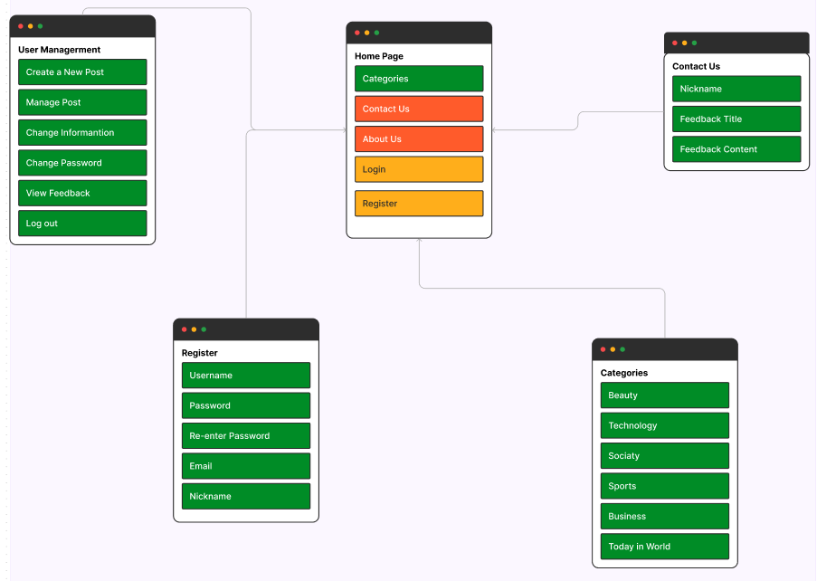

## System fucntions design

* + 1. **Login**

**Design the Login Page Interface:**

* Create a web page with the title “Login”.
* Add an icon or logo for the web page.

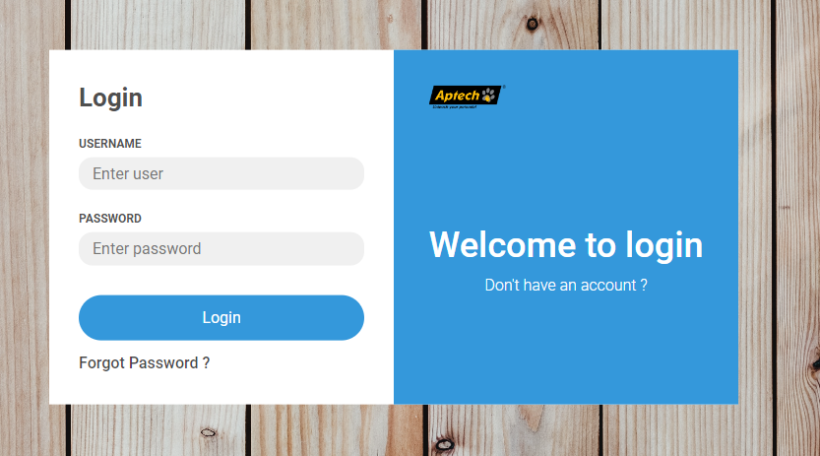

**Login Page Content:**

* Create a login form with two field: Username and Password.
* Add a “Login” button to perform the login.
* Include a “Forgot password ?” link leading to a password recovery page.
* Include a “Don’t have an account ?” link leading to a user registration page.
* Display error messages if there are invalid username or password input.

**User Interaction:**

* When the user clicks “Login” button, handle the login using the provided PHP code.
* Display error messages if there are issues with the username or password.
  + 1. **Register**

**Design the Register Page Interface:**

* The registration form includes fields for the user’s username, password, re-password, email, nickname.
* There’s a “Register” button to submit the registration form.
* There’s a “Are you logged in ?” link that allows users to navigate to the login page.

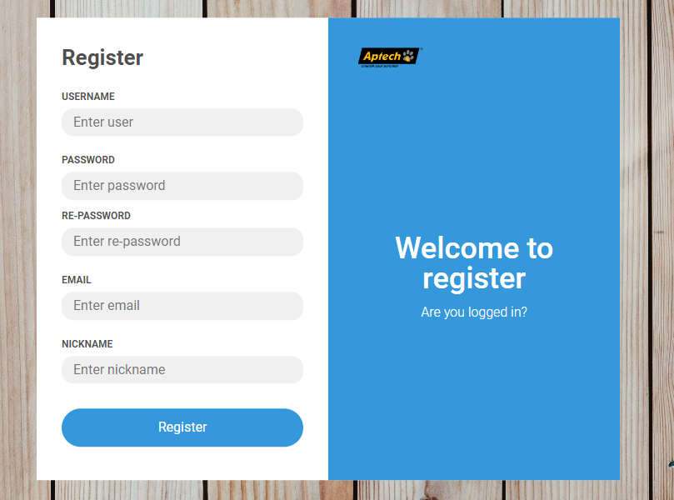

**Activity Diagram**

The activity diagram for this registration page can be described as follows:

* The User accesses the registration page
* The User enters their personal information into the registration form (username, password, re-password, email, nickname).
* When the User clicks the “Register” button, the registration data is sent to the server for processing:
  + The server-side code handles form data processing and validation. This includes checking if the username, email, nickname is unique, validating the password, and ensuring the password and re-password matching.
  + If there are any errors (eg: username already exist, email already exist, nickname already exist), an error message is displayed to the user. The registration process is halted.
  + If the data is valid and there are no errors, the user’s data is stored in the database after password hashing.
  + A success message is displayed, and the user is redirected to the login page.

**Algorithm for User Registration:**

Here is a simplified algorithm for use registration based on the provided code:

* Initialize the database connection
* If the user submits the registration form:
  + Retrieve and validate user input data (username, password, re-password, email, nickname).
  + Check if the provided username, email, nickname already exist in the database. If they exist, display an error message.
  + Verify that the password and re-password fields match. If they don’t match, display an error message.
  + If all checks pass, hash the user’s password using a secure algorithm
  + Insert the user’s registration data (username, hashed password, hashed re-password, email, nickname) into the database.
  + Display a success message.
    1. **Home Page**

**Design the Home Page Interface:**

* In the header section, there is a logo positioned on the left side of the page. In the right of the header, there is a search box where users can enter keywords to search for specific content. Next to the search box, there is an icon representing user information management. Clicking on this icon would allow users to access their account settings or user profile.
* Moving to the body section, there is a list of news articles displayed. Each news article is presented with a title that summarizes its content. Below the title, there is a short snippet providing a brief overview of the article. To indicate the popularity or user rating of each news article, a starred rate is displayed using symbols such as ★★★, ★★, or ★. Additionally, the posted time of each article is mentioned to inform users about the recency of the news.
* At the bottom of the page, in the footer section, there are several components. First, there is a pagination feature that includes numbered links to navigate between different pages of news articles. This allows users to access older or newer articles easily. Additionally, there are two links provided: "About Us" and "Contact Us."
* This layout aims to provide a user-friendly interface where users can quickly search for news, browse through articles, and access additional information or contact the website administrators if needed.

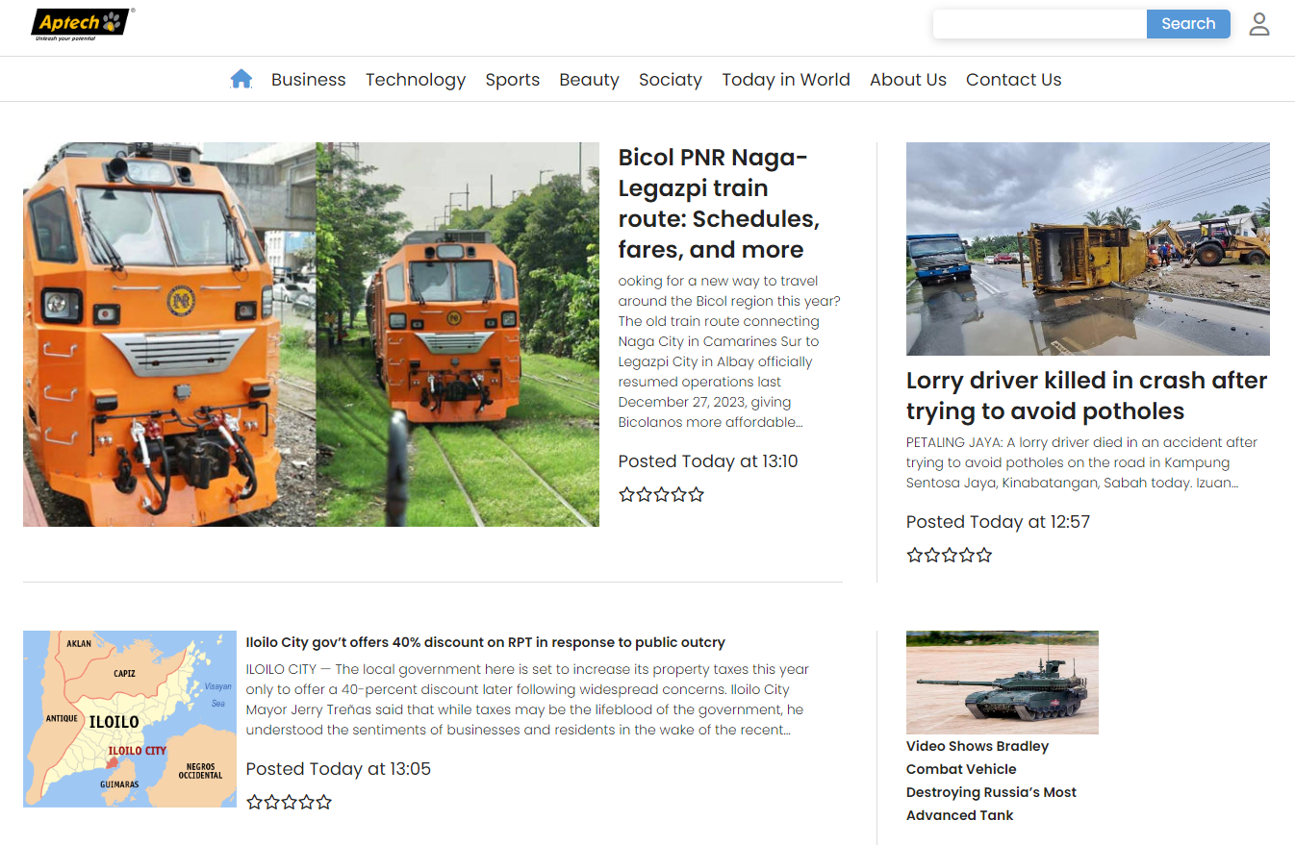 

* + 1. **Pagination**

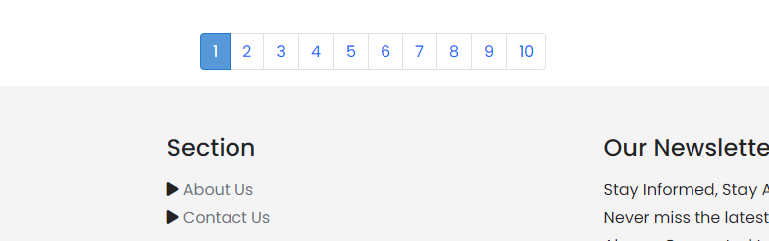Pagination is designed to facilitate easy navigation and prevent the overcrowding of content on a single page. It allows users to browse through articles chronologically or jump to a specific page of interest. By dividing the content into manageable sections, users can find the information they are looking for more efficiently.

Overall, pagination is a crucial component of a news website that enables users to explore a large volume of articles in an organized and user-friendly manner. It enhances usability and ensures a smooth browsing experience for visitors.

* + 1. **Contact Us**

**Design the Contact Us Interface:**

* Feedback Form: The feedback form is a key component of the "Contact Us" page. It typically includes fields where users can enter a title and the content of their feedback or message. The title field allows users to provide a brief summary or subject line for their message. The content field is where users can elaborate on their feedback, ask questions, or provide any other relevant information.
* Address of Our Branch: In the right side of the "Contact Us" page provides the address of the organization's branch or office. This information is useful for users who prefer to visit in person or send physical mail. The address may include details such as street name, city, state, postal code, and country. It helps users locate the physical location of the organization and facilitates offline communication.
* Location on Map: Below of the “Contact Us” page is further assist users in finding the organization's branch, it’s may display a location on a map. 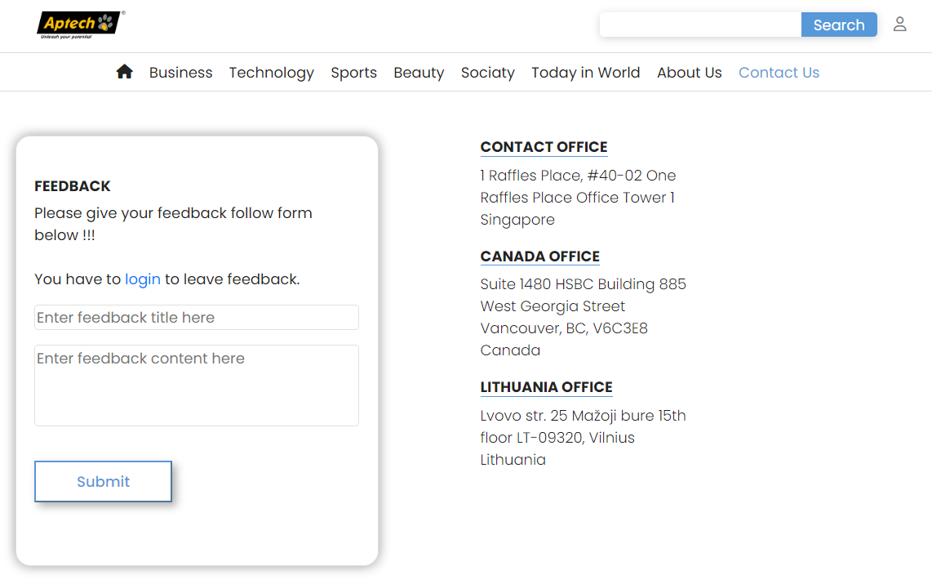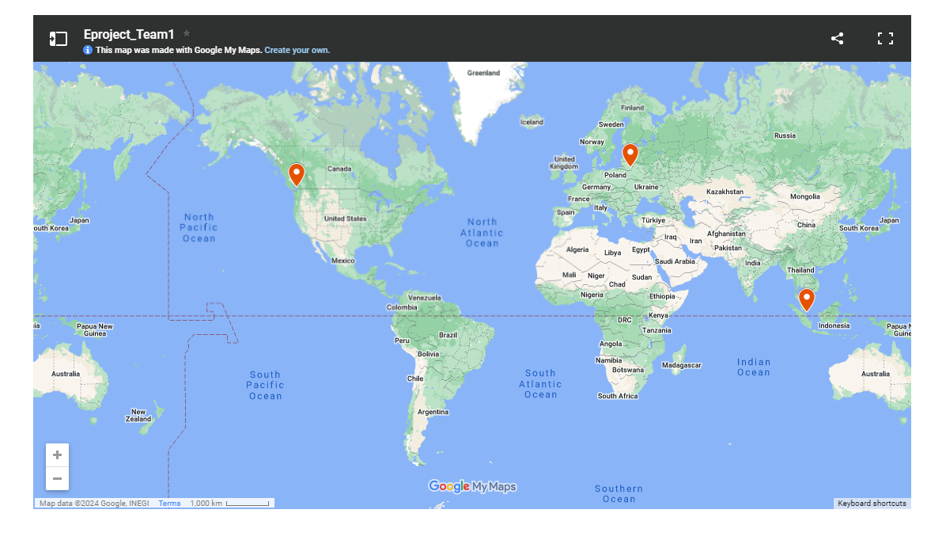
  + 1. **Create a new Post**

**Design the Create a New Post Interface:**

* **News Title:** Start by providing a concise and informative title for the news report. The title should capture the essence of the story and grab the readers' attention.
* **News Category**: Assign a category to the news report. Categories help organize news articles and make it easier for users to find relevant content. Common categories include politics, sports, entertainment, technology, health, and more. Choose the category that best aligns with the subject matter of the news report.
* **News Image:** Select a suitable image to accompany the news report. The image should be relevant to the story and visually appealing. It can help attract readers' attention and provide a visual representation of the news event. Ensure that you have the necessary rights or permissions to use the image, or alternatively, use royalty-free or licensed images from reputable sources.
* **News Content:** Compose the main body of the news report. Here, you should include the details, facts, and relevant information about the news event or story. The content should be well-structured, engaging, and provide a clear understanding of the topic.

Once you have gathered all the required information, you can store it into the database.

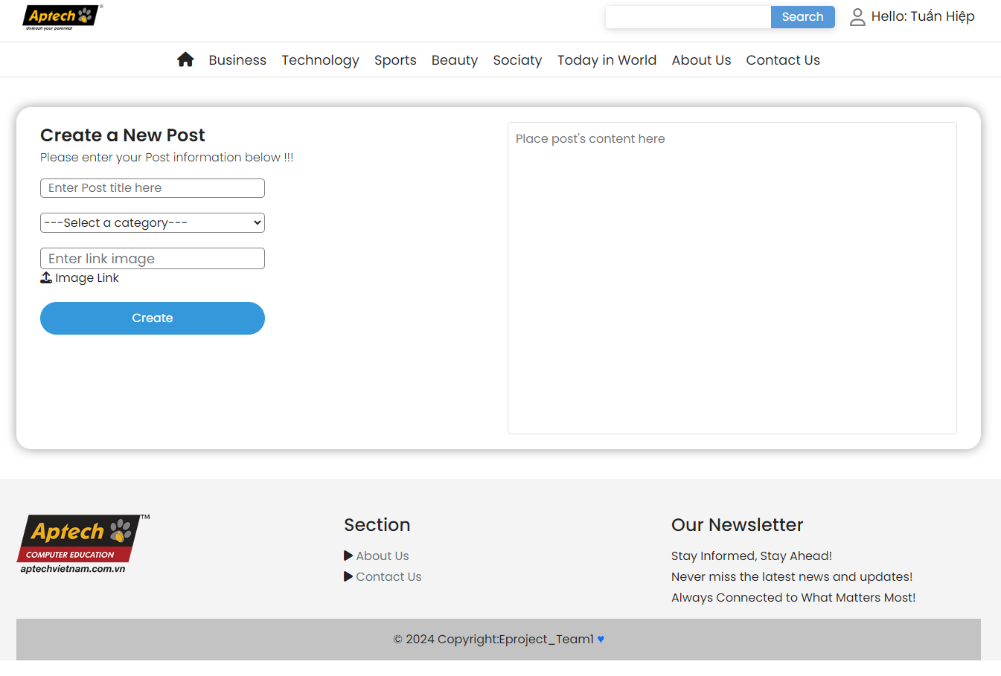

* + 1. **Manage Post**

**Design the Manage Post Interface:**

* The manage post interface is designed to provide users with a way to manage their posts efficiently. It typically displays a list of posts created by the user, each containing a title and a short content snippet. This allows users to quickly identify and locate the posts they want to manage.
* Below each post, there are two buttons: delete and update. These buttons provide the user with specific actions to perform on their posts.

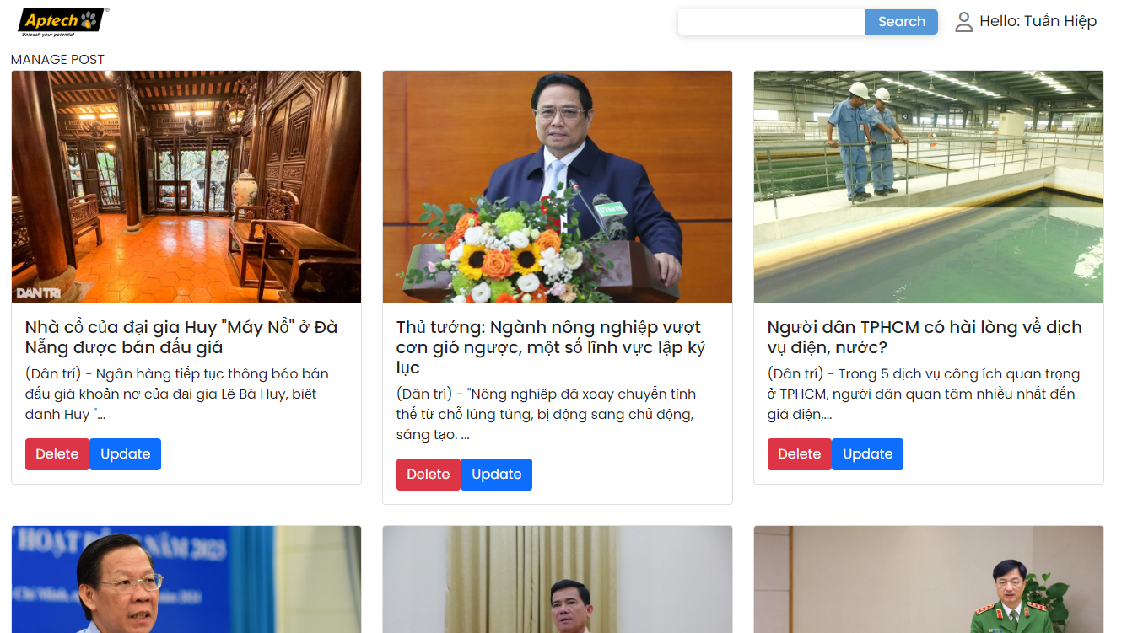

* The delete button allows users to remove a post from the platform.
* The update button enables users to edit the content of their posts. Users can make the desired changes and save the updated post. The changes will then be reflected on the platform, ensuring that the post reflects the most accurate and up-to-date information.

The manage post interface is designed to be user-friendly and intuitive, providing users with clear options to delete or update their posts. This interface empowers users to have control over their own content, allowing them to make necessary adjustments or remove posts as needed.

* + 1. **Change User Information**

**Design the Change Information Interface:**

* Create a change information form with three field: Username, email, nickname
* Add a “Change information” button to perform the Update/Change.
* Include a “Back to Home Page” link leading to a Home page.
* Raise error messages if there are invalid username, email, nickname input.
* Display Successful messages if user information was changed.

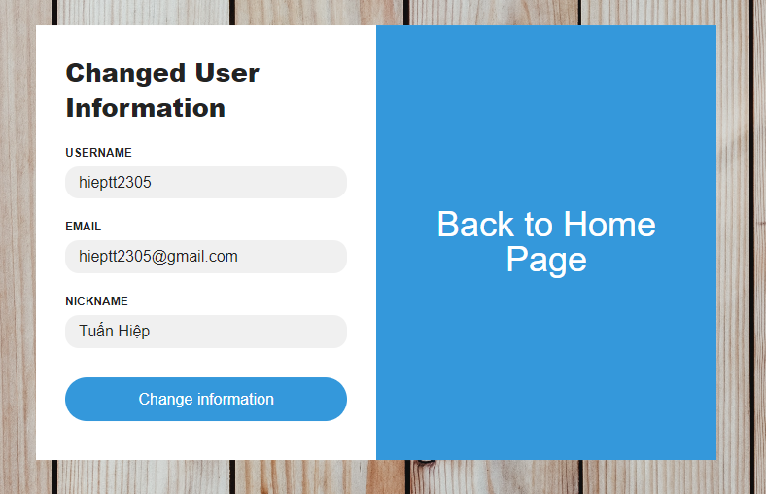

* + 1. **Change Password**

**Design the Change Password Interface:**

* Create a change password form with three field: old password, new password, re-enter new password
* All passwords are hashed passwords for security.
* Include a “Back to Home Page” link leading to a Home page.
* Raise error messages if there are old password match with new password or new password and re-enter new password not match.
* Display Successful messages if old password was changed.

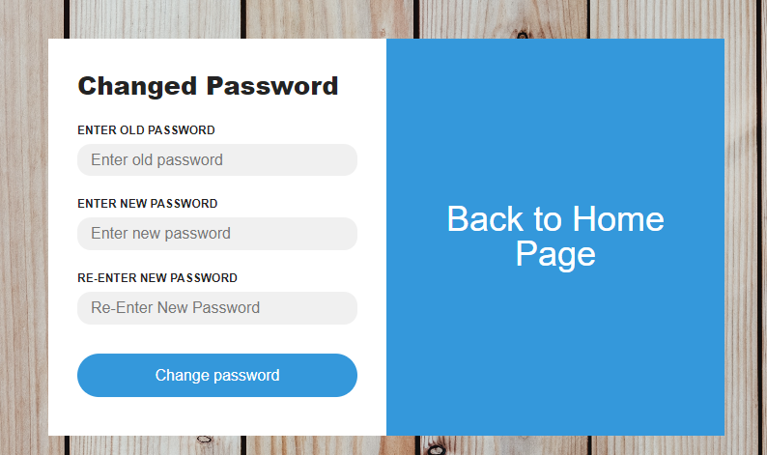

* + 1. **View Feedback Response**

**Design the View Feedback Response Interface:**

* Feedback: This section displays the original feedback submitted by the user. It typically includes a title and content, allowing users to review what they initially shared with the website or organization. The title provides a brief summary or subject line for the feedback, while the content contains the detailed information or message.
* Response: In this section, users can see the response provided by the website or organization in relation to their feedback. The response section also consists of a title and content. The title may summarize the nature of the response, while the content offers a detailed reply addressing the user's feedback, questions, or concerns.

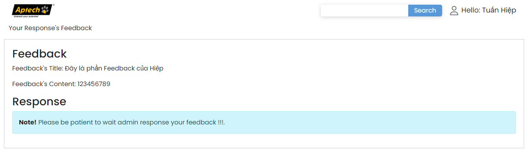

# Task sheet

|  |  |  |  |
| --- | --- | --- | --- |
| **Task** | **Start time** | **Finish time** | **Implemented by** |
| **Feasibility study phase** |  |  |  |
| Writing document | 14/01/2024 | 23/01/2024 | Trịnh Tuấn Hiệp |
| List possible features | 14/01/2024 | 14/01/2024 | Trịnh Tuấn Hiệp |
| List possible table and relations between table | 14/12/2023 | 28/12/2023 | Trịnh Tuấn Hiệp |
| 14/12/2023 | 28/12/2023 | Trịnh Tuấn Hiệp |
| Final check | 22/01/2024 | 22/01/2024 | Trịnh Tuấn Hiệp |
| **Requirement Analysis phase** |  |  |  |
| Feedback requirements | 28/12/2023 | 28/12/2023 | Trịnh Tuấn Hiệp |
| User manager requirements | 22/12/2023 | 22/12/2023 | Trịnh Tuấn Hiệp |
| User permission requirements | 22/12/2023 | 22/12/2023 | Trịnh Tuấn Hiệp |
| Search Requirements | 04/01/2024 | 10/01/2024 | Trịnh Tuấn Hiệp |
| **Design phase** |  |  |  |
| Design database | 22/12/2023 | 28/12/2023 | Trịnh Tuấn Hiệp |
| Find sample data | 25/12/2023 | 25/12/2023 | Trịnh Tuấn Hiệp |
| 25/12/2023 | 25/12/2023 | Nguyễn Việt Anh |
| 25/12/2023 | 25/12/2023 | Trần Đức Minh |
| Insert database | 26/12/2023 | 02/01/2023 | Trịnh Tuấn Hiệp |
| Design layout | 25/12/2023 | 02/01/2023 | Nguyễn Minh Đức |
| **Development phase** |  |  |  |
| Header | 05/01/2024 | 19/01/2024 | Nguyễn Minh Đức |
| Footer | 05/01/2024 | 19/01/2024 | Dương Văn Hiệp |
| Design Logo | 05/01/2024 | 19/01/2024 | Trần Đức Minh |
| FE Login demo | 05/01/2024 | 07/01/2024 | Trần Đức Minh |
| FE Register demo | 05/01/2024 | 07/01/2024 | Trần Đức Minh |
| FE Login fully | 07/01/2024 | 19/01/2024 | Nguyễn Minh Đức |
| FE Register fully | 07/01/2024 | 19/01/2024 | Nguyễn Minh Đức |
| Homepage | 05/01/2024 | 19/01/2024 | Nguyễn Minh Đức |
| BE Login & Register | 14/12/2023 | 28/12/2023 | Trịnh Tuấn Hiệp |
| Improve appearance & fix bug in header, footer, homepage, login, register | 05/01/2024 | 19/01/2024 | Trịnh Tuấn Hiệp |
| 05/01/2024 | 19/01/2024 | Nguyễn Minh Đức |
| About Us | 05/01/2024 | 19/01/2024 | Dương Văn Hiệp |
| FE Contact Us | 05/01/2024 | 19/01/2024 | Dương Văn Hiệp |
| BE Contact Us | 05/01/2024 | 12/01/2024 | Nguyễn Việt Anh |
| Category page | 05/01/2024 | 12/01/2024 | Nguyễn Minh Đức |
| Pagination | 05/01/2024 | 12/01/2024 | Trịnh Tuấn Hiệp |
| FE Admin site | 17/01/2024 | 21/01/2024 | Nguyễn Việt Anh |
| 17/01/2024 | 21/01/2024 | Nguyễn Minh Đức |
| BE Admin site | 05/01/2024 | 12/01/2024 | Nguyễn Việt Anh |
| Detail Page | 05/01/2024 | 19/01/2024 | Dương Văn Hiệp |
| 05/01/2024 | 19/01/2024 | Nguyễn Minh Đức |
| User Managers | 05/01/2024 | 19/01/2024 | Nguyễn Minh Đức |
| 05/01/2023 | 19/01/2024 | Trịnh Tuấn Hiệp |
| **Testing phase** |  |  |  |
| Test page layout | 10/01/2023 | 22/01/2024 | Nguyễn Minh Đức |
| Test sign in / sign up / sign out function | 14/01/2024 | 22/01/2024 | Trịnh Tuấn Hiệp |
| Test recover password function | 14/01/2024 | 22/01/2024 | Trịnh Tuấn Hiệp |
| Test search function | 14/01/2024 | 22/01/2024 | Trịnh Tuấn Hiệp |
| Test feedback function | 14/01/2024 | 22/01/2024 | Trịnh Tuấn Hiệp |
| Test user manager functions | 14/01/2024 | 22/01/2024 | Trịnh Tuấn Hiệp |
| Test database query result | 14/01/2024 | 22/01/2024 | Trịnh Tuấn Hiệp |
| **Deployment phase** |  |  |  |
| Source Code of project | 20/01/2024 | 23/01/2024 | Trịnh Tuấn Hiệp |
| Review Video | 20/01/2024 | 23/01/2024 | Nguyễn Việt Anh |
| Document | 20/01/2024 | 23/01/2024 | Trịnh Tuấn Hiệp |
| Slide | 20/01/2024 | 23/01/2024 | Dương Văn Hiệp |
| Submit Task Sheet | 20/01/2024 | 23/01/2024 | Trịnh Tuấn Hiệp |

# Validation Checklist

|  |  |  |
| --- | --- | --- |
| **SCREEN** | **PROBLEMS** | **STATUS** |
|  | **Login Page:**  When user do not fill username and password, then click submit button. It’ll raise error. | Done |
|  | **Reset Password Page:** When user do not fill username and email, then click submit button. It’ll raise error. | Done |
|  | **Home Page:** user can switch freely between categories without error | Done |
|  | **Contact Us Page:** user have to login before leave comment | Done |
|  | **Search box:** when user leave it blank and click “Search” button. It’s show nothing | Done |
|  | Change User Information: when user blank username/ email/ nickname. It’s will raise noted | Done |
|  | Change Password: when user blank old password/ new password/ re-enter new password. It’s will raise noted | Done |
|  |  |  |